COVID19 and its impact on investments

# 

# ABSTRACT

This literature review is an attempt to capture the investment scenario since the World Health Organization declared it a pandemic on 11th March 2020. Although the novel coronavirus and the health scare it posed had been hitting the news worldwide and gaining traction for a few months before being declared a pandemic, its formal effects, especially on world economies and financial markets began to appear, post the WHO declaration. The biggest impact of Covid19, apart from the obvious health disaster, has been on the global economy and people’s incomes. The global financial market has evolved dramatically in the last few decades and the coronavirus pandemic in a vastly interconnected world is unprecedented since the last major pandemic that struck was around 100 years ago (1918-1920: The Spanish Flu). A global recession triggered by the economic effects of the pandemic is imminent, and experts have argued that we are already in the throes of a global financial depression akin to that of the 1920-30s.

# INTRODUCTION

Through the months of January and February 2020, the global financial markets remained resilient against the fallout from COVID-19. Perhaps, the perception was that the virus would remain confined to China, its place of origin or that modern healthcare systems around the world would successfully tackle the emerging epidemic. Even if the disease became a pandemic, the assumption was that the markets would react the same way they did in previous cases of virus crises like SARS or MERS, with a temporary dip followed by a quick rebound. By early March, the skepticism turned into reality with significant fallout on the global economy.

As of June 15th, 2020, there have been 7,761,609 confirmed cases of COVID-19 including 430,241 deaths reported to WHO. To put the infection rate of COVID-19 into perspective, the total number of SARS virus in 2002-2003 was 8096, killing approximately 770 people. While COVID-19 is substantially more infectious than SARS, it is significantly less fatal, with a case fatality ratio of 3.5% (compared to 9.6% for SARS). The rapid spread of the novel coronavirus led to massive lockdowns in several countries, inhibiting business activities and economic growth.

The economic impact of COVID-19 can be subdivided into:

1. **Supply-side shock:** China is the world’s manufacturing and distribution hub for most goods worldwide. To reduce the risk of infection, China shut its major hubs of business activity for around 2 months. This severely affected global supply chains leading to a shortage of many goods around the world. The ‘just-in-time’ inventory system, on which many companies operate and the failure to contain the spread of the virus, further aggravated the situation.
2. **Demand-side shock:** Government-mandated lockdowns in several countries, limited consumption to essentials only, thereby halting all business activities that required public gatherings (tourism, cinema, sports events). Travel restrictions and stay-at-home orders imposed by many countries led to a significant slump in the BEACH industries- booking, entertainment, airlines, cruises, and hotels. While the spread of the virus increased the online demand for goods and services, this has not been enough to compensate for the decline in in-store activity.
3. **Global financial market shock:** The credit market took a hit as investors switched from holding risky assets like equities into perceived safe-haven assets, such as US government bonds. International credit markets saw a lack of liquidity reflected in the sharp widening of credit spread as banks and investors adjusted their risk assessments to account for the deteriorating economic environment.

Unprecedented events like US oil futures slumped into negative while Brent crude oil prices hit a 21-year low in April 2020. The glut in oil overwhelmed the world’s limited storage facilities, triggering a wave of selling by oil traders in April. Closer to home, the cost of the Indian basket of crude, which comprises Oman, Dubai, and Brent crude, averaged $56.43 and $69.88 per barrel in FY18 and FY19, respectively, and $19.90 in April, according to data from the Petroleum Planning and Analysis Cell.

# 

# Global Overview

The following section gives a picture of the global stock indexes from Q3 FY 2019-2020 till 22 June 2020 with a trend line indicating a 30-day moving average.

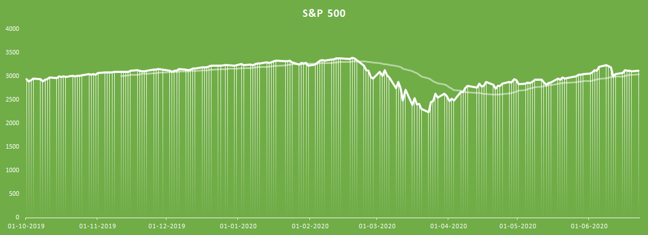

|  |
| --- |
|  |
|  |

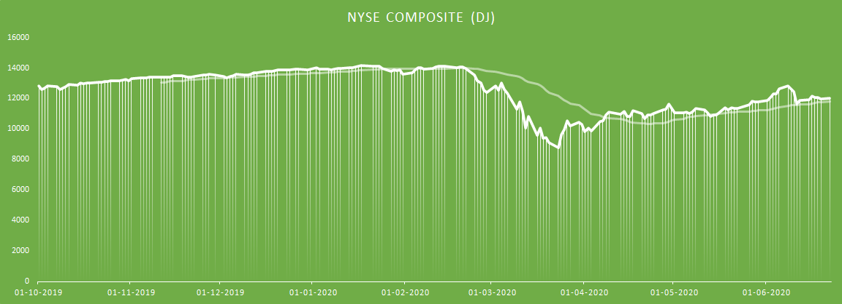

The above are some of the popularly followed indices, all of which show a steady upward trend since October 2019 and a sharp dip following lockdowns around the world owing to the novel coronavirus pandemic.

### Top Global banks

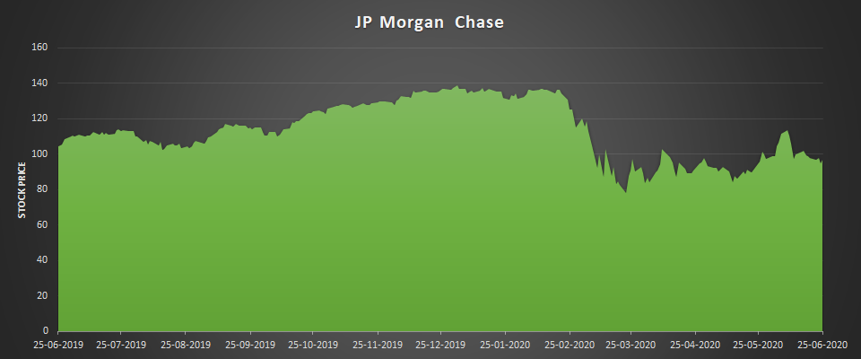

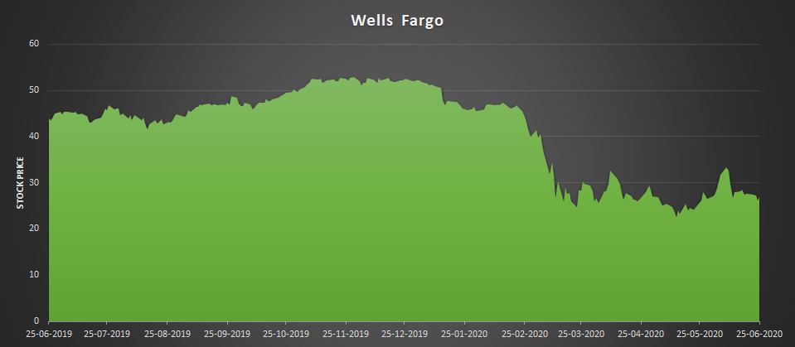

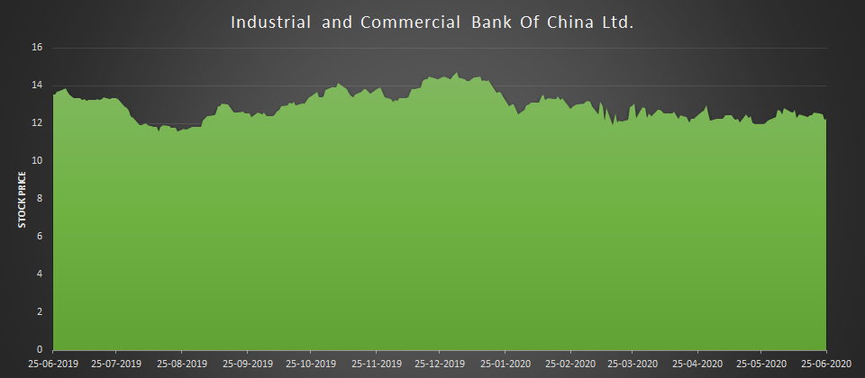

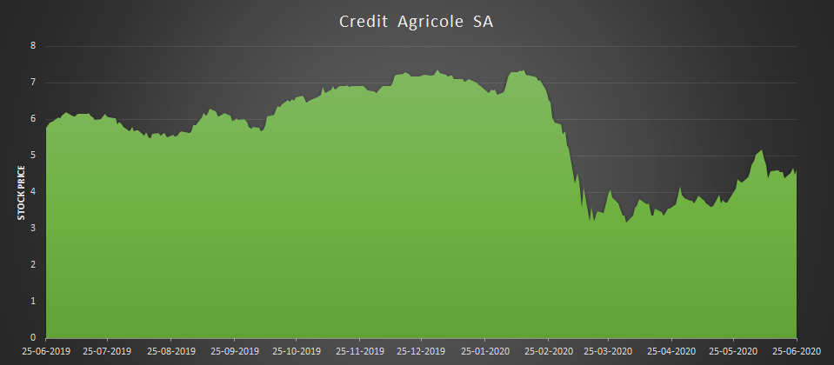

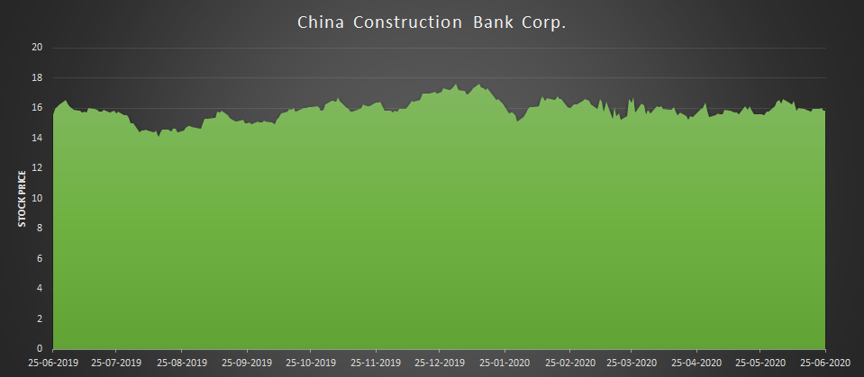

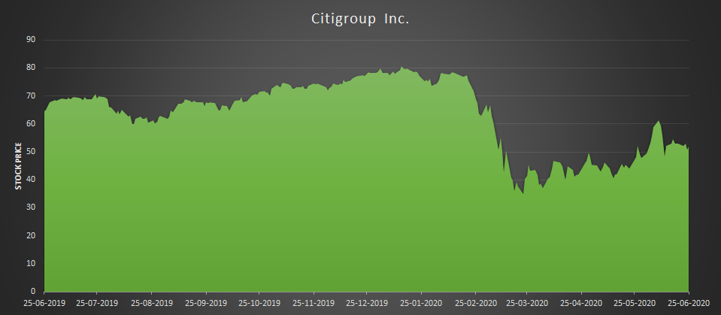

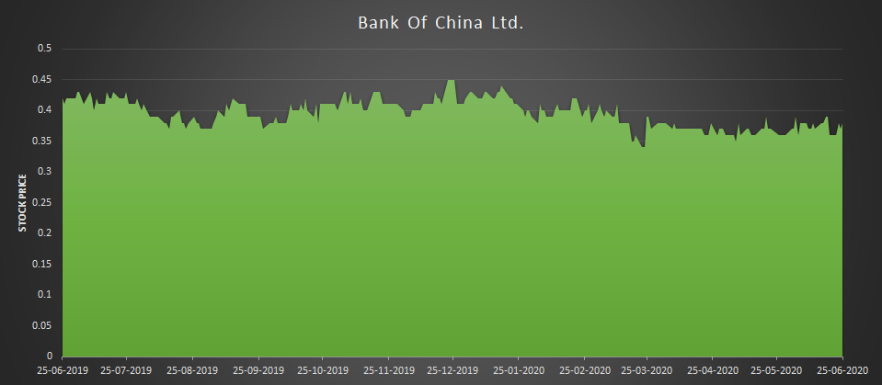

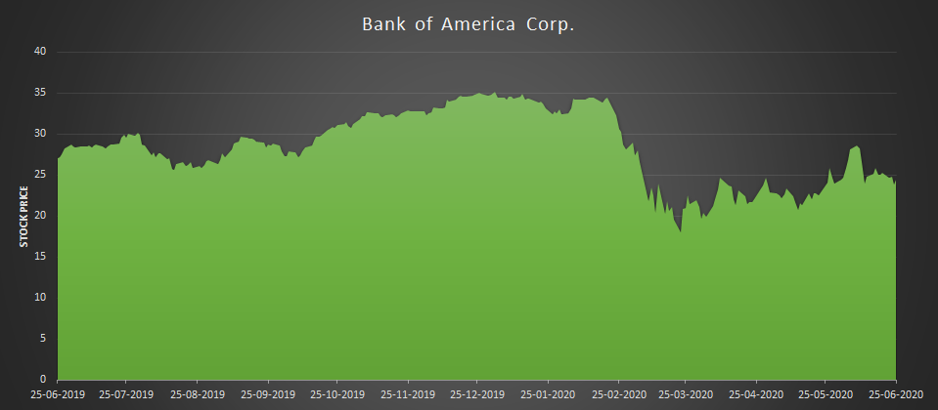

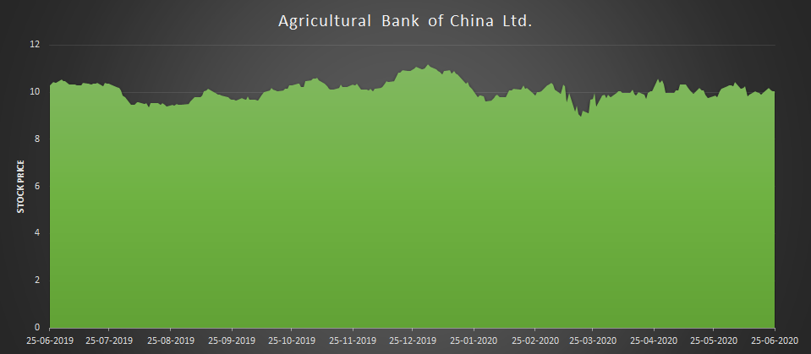

National Indexes Asia (excluding India - covered later)

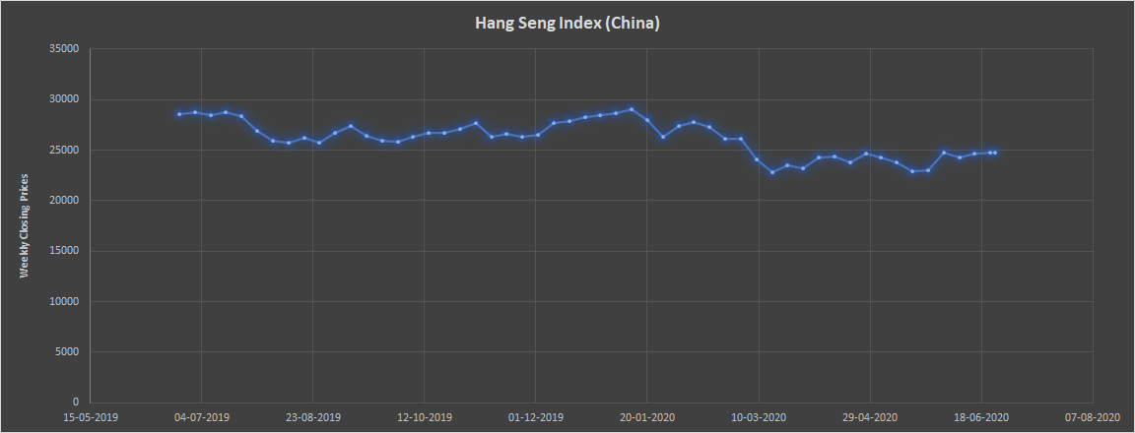

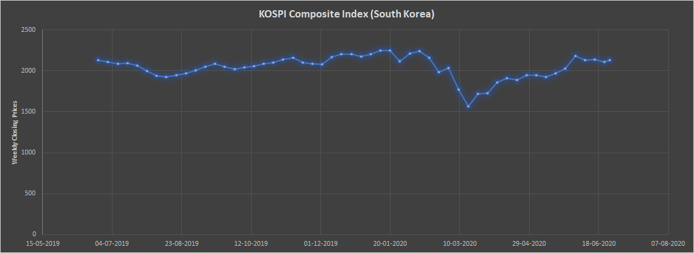

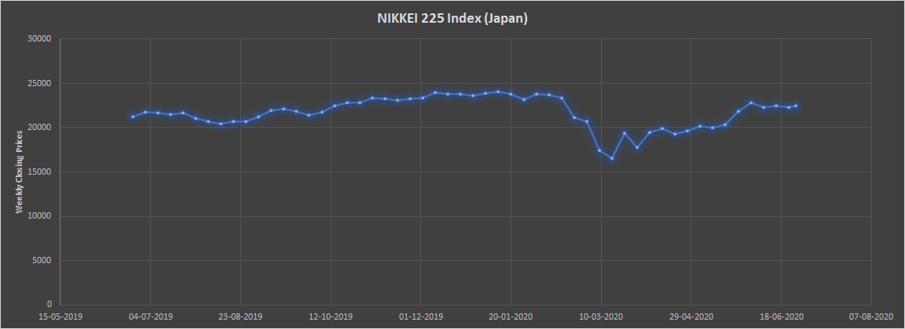

## Debt Market (US)

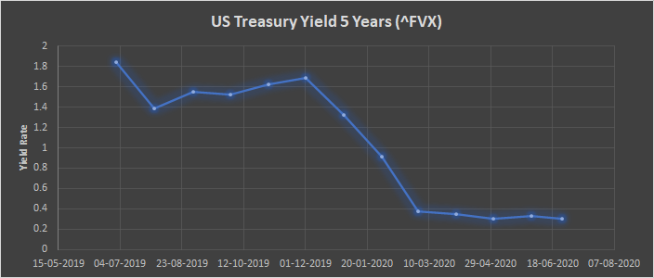

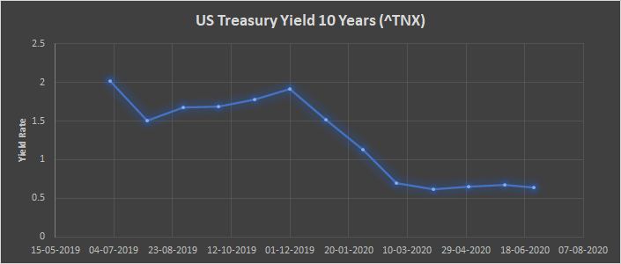

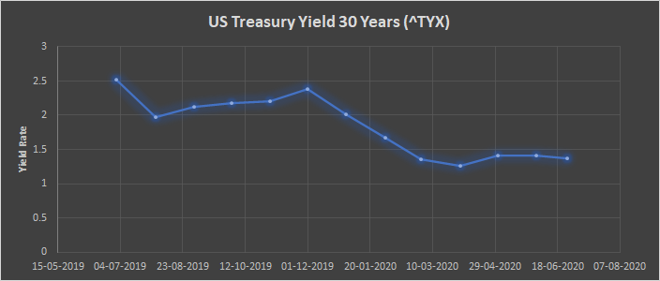

Global debt capital markets activity (not including high yield) reached $2167bn in the first three months of 2020 – the highest quarterly total on record. It continued to be robust throughout April and into May. “Early on in the disruption, we saw a typical reaction during a liquidity or credit crunch,” says John Hines, head of high grade debt capital markets (DCM) at Wells Fargo. “We saw very little demand from investors for commercial paper and robust selling of short-dated corporate bonds as investors looked to raise cash. As a result, we saw the primary market pause in early March.” But despite the volatile market conditions, the drive to access cash began to push issuers back into the market. What started as a slow trickle became a deluge by the middle of March as market confidence grew, and a string of record-breaking weeks and months for corporate bond issuance followed. In the US, corporate issuance reached $194bn and $226bn in March and April, respectively, while in Europe this was $56bn and $101bn.

**Covid19 response bonds** - As populations worldwide grapple with the Covid-19 pandemic, a wave of social bonds funding healthcare or economic response measures have been printed by supranational agencies such as the World Bank, the European Investment Bank and the Inter-American Development Bank, as well as several national agencies and sovereigns.

**Social bonds –** which fund projects with positive social outcomes – had previously been a relatively under-used category, especially compared with their better-known cousins green bonds. Many believe the world is now witnessing a defining moment for the social bond. There has already been a higher volume of social bonds issued in 2020 than came to market during the whole of 2019, and by the end of April 2020, there had been five times more social bonds issued than in the same period in 2019.[1]

## Debt Market – India

The Indian debt market is largely a wholesale market with a majority of institutional investors comprising of mainly banks, financial institutions, mutual funds, EPFO, insurance companies and corporates. The concentration of these large players has resulted in the debt markets being fairly skewed, evolving into a wholesale & bilaterally-priced trades. It also lacks the retailness and the contractual transparency that the Indian capital markets have been able to build in the past 2 decades. Structurally, the debt market remains firmly skewed towards government securities (G-secs). The largest investor group in the G-secs market are the banks, due to their regulatory requirement to invest into SLR (statutory liquidity ratio).

**Corporate Bonds –** The Indian corporate bond market has low & unstable trading volumes. The corporate bond market remains largely about top-rated financial and public sector issuances. The domestic debt market in India amounts to about 67% of GDP while the size of India’s corporate bond market is a mere 16% of GDP — compared with 46% in Malaysia, and 73% in South Korea.[2]

Bond sales dropped to a quarter in March as coronavirus hit operations, investment and expansion across the industry. As traders began working from home which meant they were just doing bare minimum trades to cover their positions, and open market hours shortened, inefficiency crept in.

Money managers are now seeking liquidity in government bonds even as they eye top-rated corporate paper trading at high spreads to the sovereigns. Firms have only raised Rs 35,946 crore in March 2020 so far via bonds as against Rs 150,536 crore in March 2019, shows data compiled by JM Financial.

A drop in capital expenditure due to freeze in activity has reduced need to raise money for corporates. The lower-rated companies in the market are paying 30-50 basis points extra to avail funds. Also, bond trading has dried up as desks are operating at thin capacity and bond traders forced to work from home. The bid-ask differential between the bonds of top-rated private sector companies and the benchmark Gsec has widened up to 200 basis points, compared with 100-120 basis points two weeks ago.[3]

**Revised T-Bill rates by RBI -**

|  |  |  |  |  |  |  |
| --- | --- | --- | --- | --- | --- | --- |
| T-Bill rates | **Jun. 21 2019** | **May 22**  **2020** | **May 29**  **2020** | **Jun. 5**  **2020** | **Jun. 12**  **2020** | **Jun. 19**  **2020** |
| 91-Day Treasury Bill (Primary) Yield | 5.98 | 3.28 | 3.19 | 3.35 | 3.41 | 3.29 |
| 182-Day Treasury Bill (Primary) Yield | 6.10 | 3.75 | 3.40 | 3.45 | 3.51 | 3.48 |
| 364-Day Treasury Bill (Primary) Yield | 6.13 | 3.79 | 3.41 | 3.55 | 3.58 | 3.56 |
| 10-Year G-Sec Par Yield (FBIL) | 6.91 | 5.75 | 5.79 | 5.83 | 5.81 | 5.86 |

**Certificate of Deposit-** FBIL announces the benchmark rates for Certificates of Deposit ( FBIL-CD) on a daily basis except Saturdays, Sundays and public holidays at 5.30 PM. FBIL has developed the FBIL- CD, a new benchmark for the money market based on traded CDs reported on the FTRAC platform of CCIL up to 5 PM. FBIL-CD is announced for seven tenors of 14 days, 1 month, 2 months, 3 months, 6 months, 9 months and 12 months.

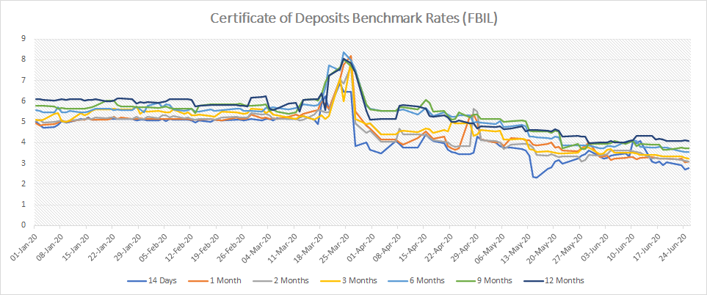

**Commercial Papers-** Commercial paper is a money-market security issued (sold) by large corporations to obtain funds to meet short-term debt obligations (for example, payroll) and is backed only by an issuing bank or company promise to pay the face amount on the maturity date specified on the note.

As with any other type of bond or debt instrument, the issuing entity offers the paper assuming that it will be in a position to pay both interest and principal by maturity. It is seldom used as a funding vehicle for longer-term obligations because other alternatives are better suited for that purpose. Since March 2020, more than 100 commercial papers have been issued and listed on BSE (<https://www.bseindia.com/markets/debt/DisclosureDocumentCommercialPapers.aspx>) with maturity tenures of roughly 1-1.5 years. Such a massive listing of commercial papers by large corporations and banks can be attributed to the loss of business due to lockdown and the consequential cash crunch.

**Debentures-** Debentures are long-term financial instruments issued by a company for specified tenure with a promise to pay fixed interest to the investor. Debentures are of two types, namely convertible debentures and non-convertible debentures (NCD). Non-convertible debentures (NCD) are those which cannot be converted into shares or equities. Debentures are more like corporate bonds except without collateral.

With cash flows suddenly drying up due to Covid19 lockdown, corporates need liquidity support, particularly in the short run. Several countries have taken extraordinary steps to deal with the crisis. Central banks have resorted to the use of unconventional monetary policy tools in order to ensure adequate system level liquidity. Starting with the long-term repo operations (LTRO), the Reserve Bank of India (RBI) has moved quite swiftly towards targeted liquidity provision, called the targeted long-term repo operations (TLTRO). The idea is to push money via banks at the current repo rate to the “sectors and entities experiencing liquidity constraints and/or hindrances to market access”.

Towards this objective, the RBI recently opened the TLTRO 2.0 window. As per the RBI, the “funds availed under TLTRO 2.0 shall be deployed in investment grade bonds, commercial paper (CPs) and non-convertible debentures (NCDs) of Non-Banking Financial Companies (NBFCs)”. Out of the maximum ₹50,000 crore available through this window, the RBI conducted the first tranche of TLTRO on April 23, 2020. However, it received lukewarm response from the market — a total bids of ₹12,850 crore were received with a bid cover ratio of 0.5.

Further, the RBI opened another special liquidity facility for mutual funds for ₹50,000 crore to ease their liquidity pressures. This scheme was meant for “extending loans, and undertaking outright purchase of and/or repos against the collateral of investment grade corporate bonds, commercial papers (CPs), debentures and certificates of Deposit (CDs) held by MFs.” As per the RBI’s press release on Money Market Operations, only ₹2,430 crore was injected through this window.[4]

**Fixed Deposit-** In a new set of measures to reduce the impact of coronavirus lockdown on the economy, the Reserve Bank of India (RBI) on 22nd March, decided to cut the repo rate by 40 basis points from 4.4 per cent to 4 per cent. The reverse repo rate was also reduced by 40 basis points to 3.35 per cent.

**RBI rate cut means**

— Interest income from FDs is likely to fall further

— The rate cut comes as a pain also for senior citizens dependent on interest income from their FD investments

After RBI's previous rate cut in March, the country's largest lender State Bank of India had announced a reduction in fixed deposit interest rate by up to 50 bps. The rates were further revised on May 12, 2020. Other major banks have also continued lowering interest rates on fixed deposits.[5]

**Government Securities-** Government securities, popularly known as G-Secs, are issued by Reserve Bank of India (RBI) on behalf of the central or state governments. These securities are absolutely risk-free and guaranteed by the government. G-Secs are more lucrative than bank fixed deposits for the following reasons. First, they are backed by the government. In fixed deposits banks deduct TDS whereas in the case of T-bills it is the responsibility of the investor to pay the necessary taxes on the interest income, if applicable. Government bonds are available for longer duration maturities, say, five or ten years but such long duration fixed deposits are not available. By all means, G-secs is a better option than bank fixed deposits.[6]

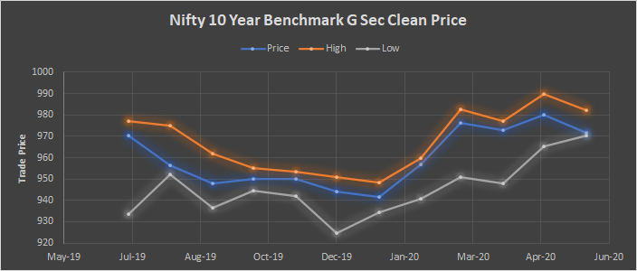

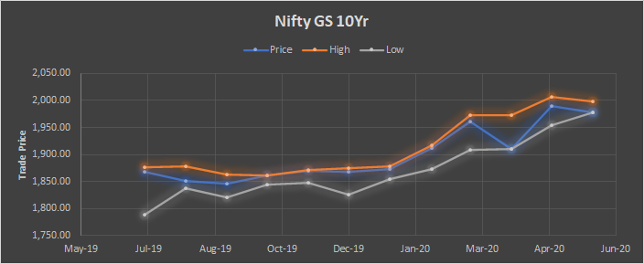

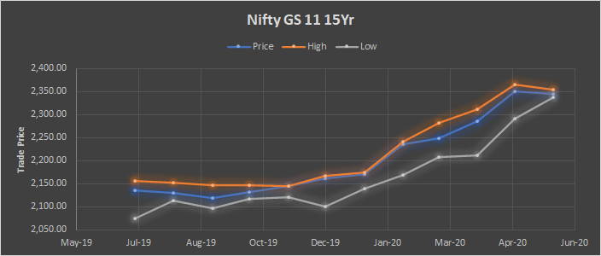

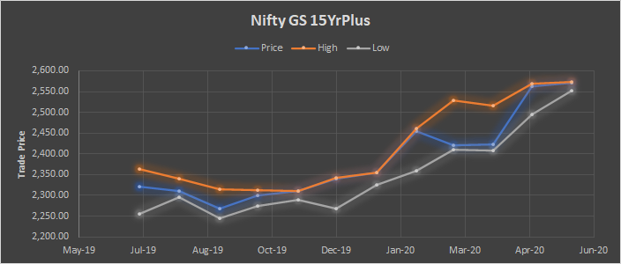

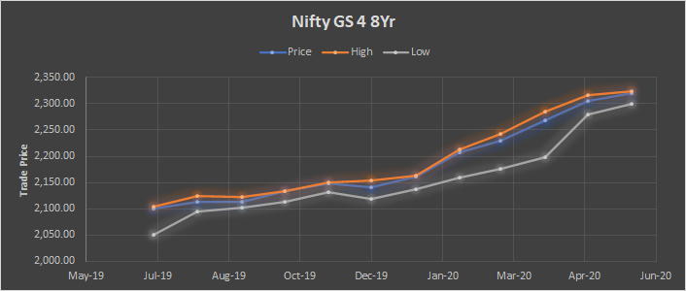

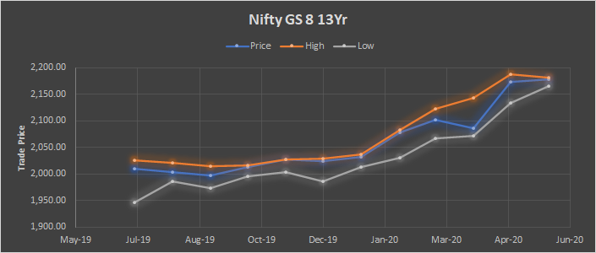

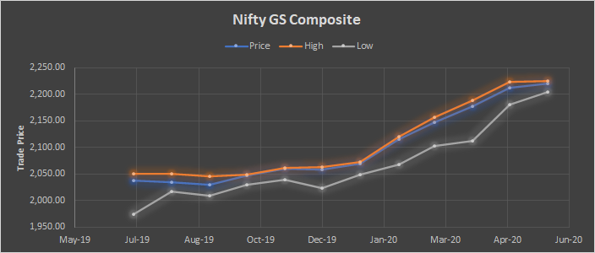

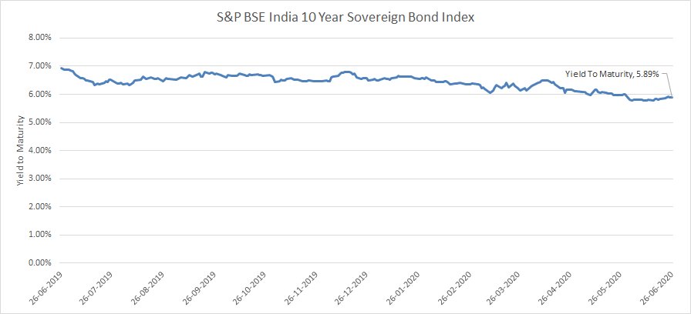

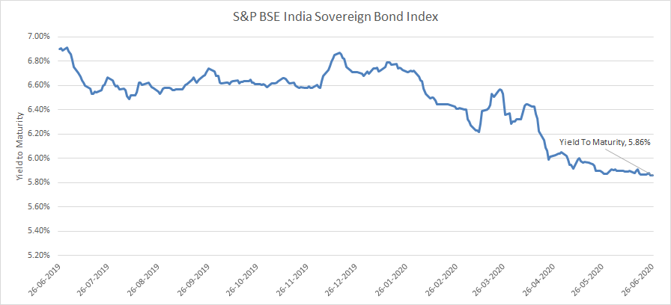

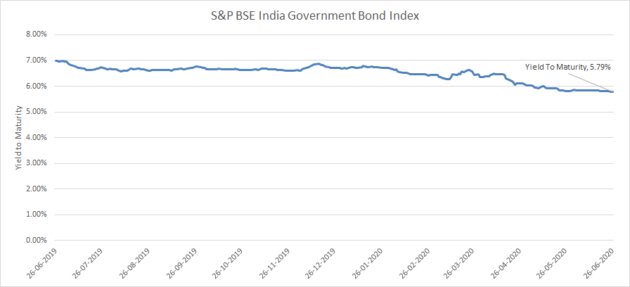

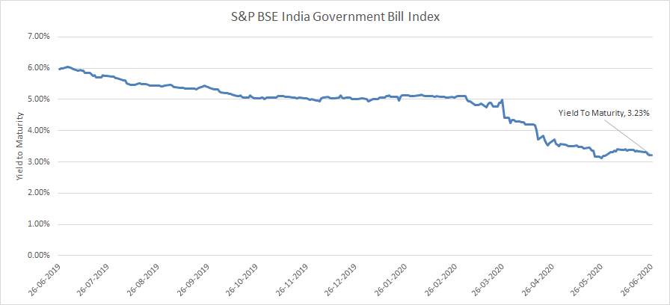

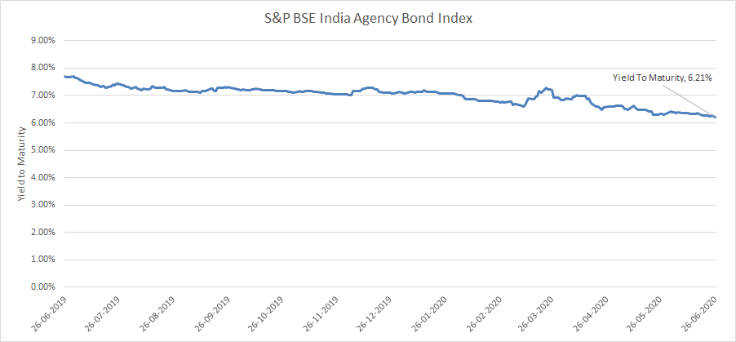

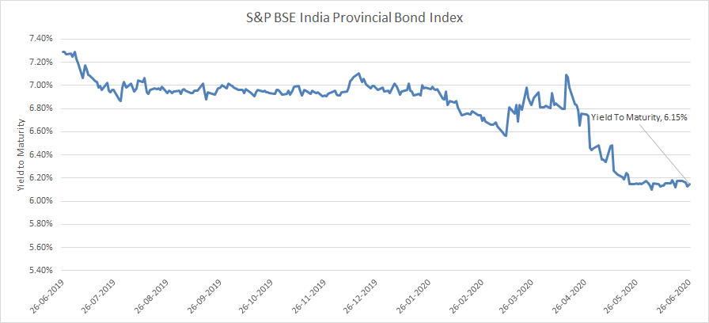

**National Savings Certificates-** National Savings Certificates or NSC is a small savings scheme with low risk and high interest rates. The interest rates for NSC get revised every quarter. The shrinking economy due to Covid19 and the consequent halt to businesses have resulted in shifts and adjustments made to several securities, bringing down the savings interest rate for NSC from 7.9% in Q4 FY 2019-2020 to 6.8% in Q1 FY 2020-2021.

EQUITY MARKET - India

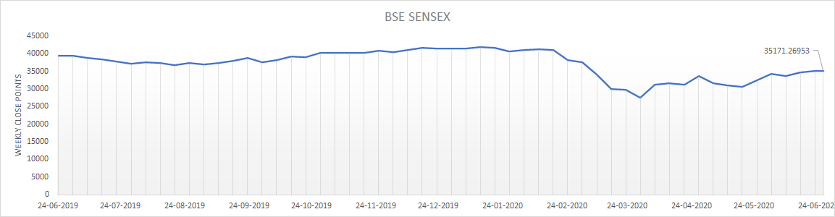

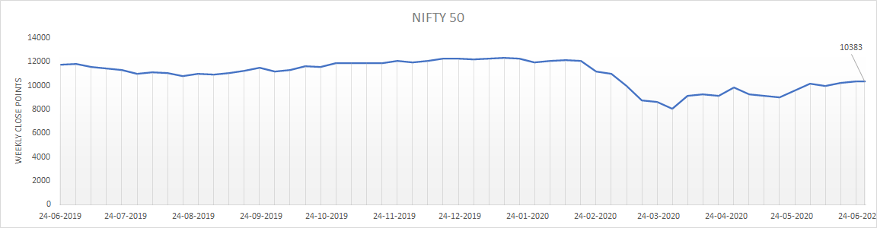

Pre COVID-19, market capitalisation on each major exchange in India was about $2.16 trillion. The 2019 stock market rally was limited to 8-10 stocks within the large caps. The Sensex returned around 14% (excluding dividends) for the year 2019 but prominently featured blue-chip companies such as HDFC Bank, HDFC, TCS, Infosys, Reliance, Hindustan Unilever, ICICI Bank and Kotak Bank, without which Sensex returns would have been negative. However, in the start of 2020, there was overall recovery which led to both NSE and BSE traded at their highest levels ever, hitting peaks of 12,362 and 42,273 respectively. At the beginning of the year, there were close to 30 companies that were expected to file IPO’s. The market conditions were generally favourable as they witnessed record highs in mid-January.

Ever since COVID 19, markets loom under fear as uncertainty prevails. lt has sent markets around the world crashing to levels not witnessed since the Global Financial Crisis of 2008. **Following the strong correlation with the trends and indices of the global market as BSE Sensex and Nifty 50 fell by 38 per cent. The total market cap lost a staggering 27.31% from the start of the year.** The stock market has reflected the sentiments this pandemic unleashed upon investors, foreign and domestic alike. Companies have scaled back; layoffs have multiplied and employee compensations have been affected resulting in negligible growth in the last couple of months. Certain sector such as hospitality, tourism and entertainment have been impacted adversely and stocks of such companies have plummeted by more than 40%.[7]

A Comparison of Pre and Post COVID View of Indian Stock Markets

|  |  |  |  |  |
| --- | --- | --- | --- | --- |
|  | **Indexes-14 Jan 20** | **Indexes-23 Mar 20** | **Indexes-24 Apr 20** | **Indexes 26 June** |
| **Nifty 50** | 12,362 | 7,610 | 9,154 | 10,383 |
| **Sensex** | 41,952 | 25,981 | 31,327 | 35,171 |

**S&P BSE Small Cap**

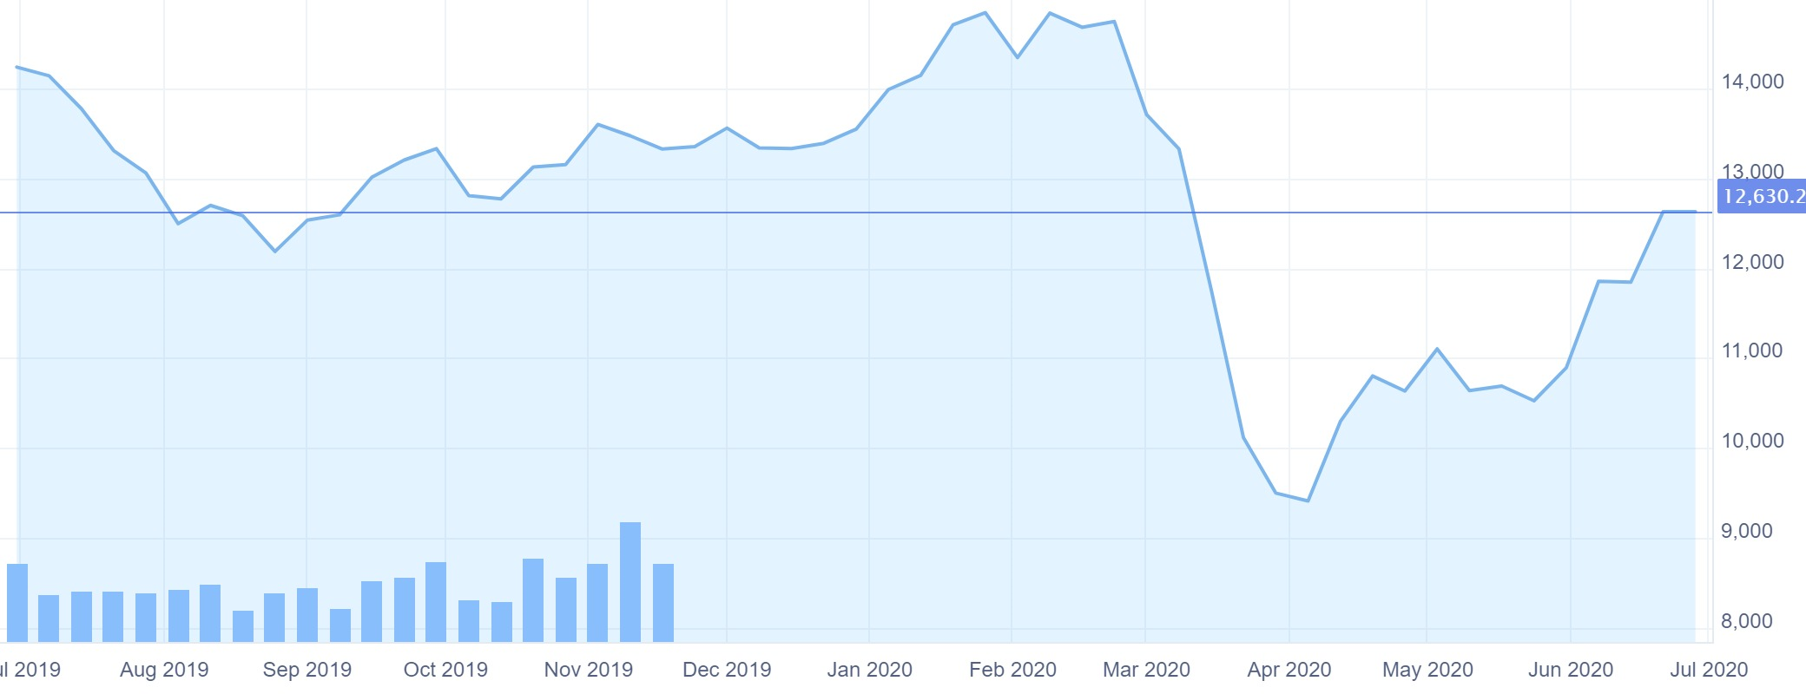**S&P BSE Mid Cap**

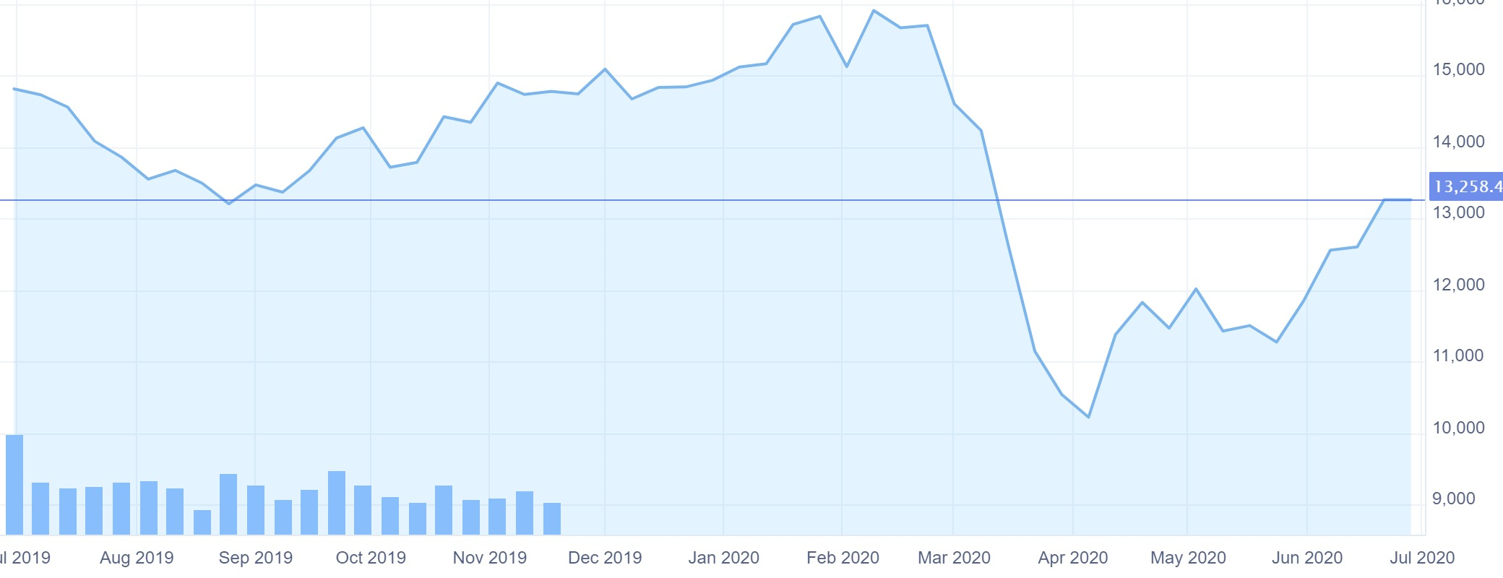

**S&P BSE-500**

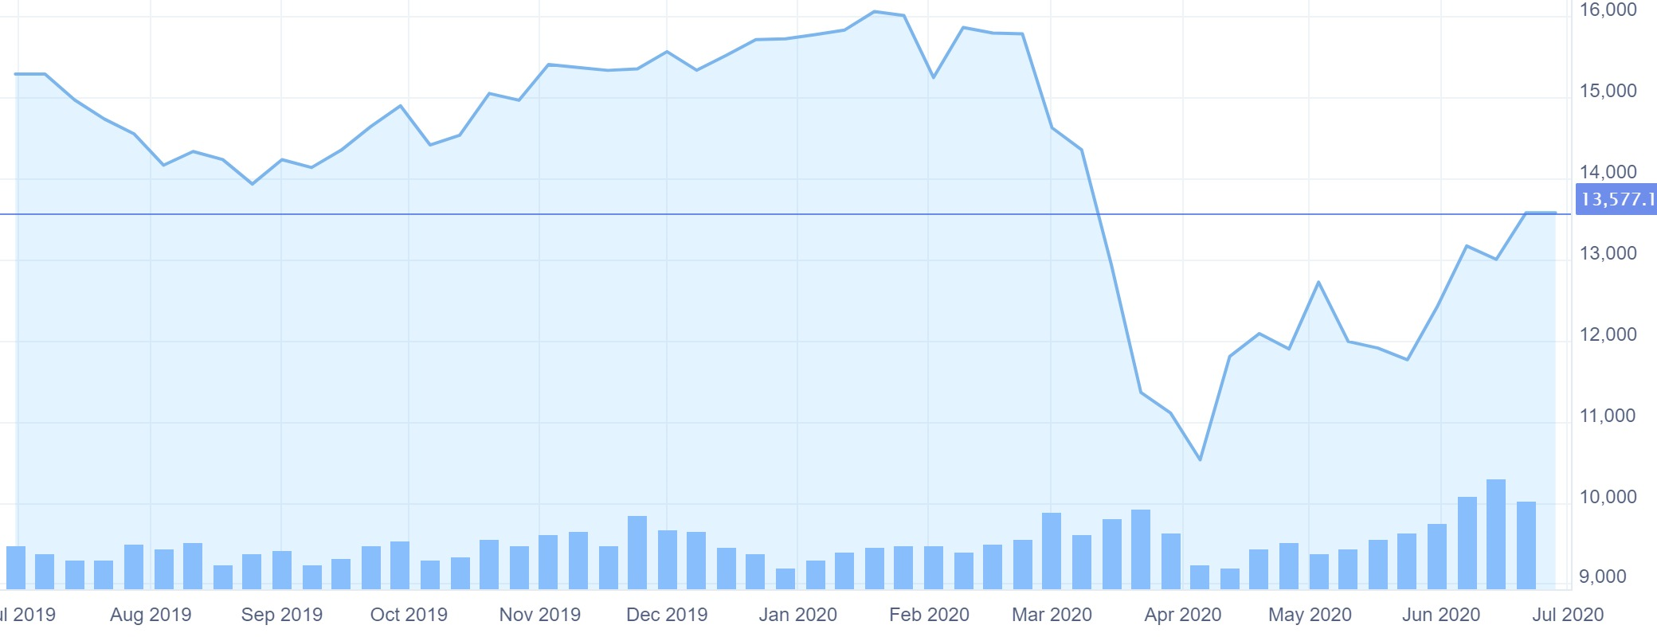

**NIFTY Smallcap 100**

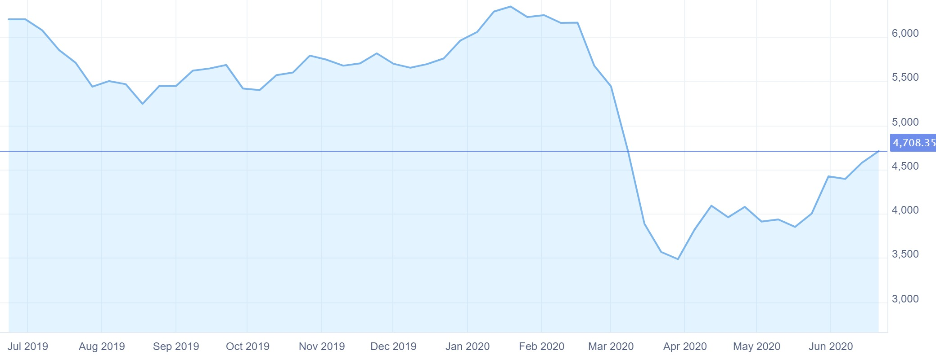

**NIFTY Midcap 100**

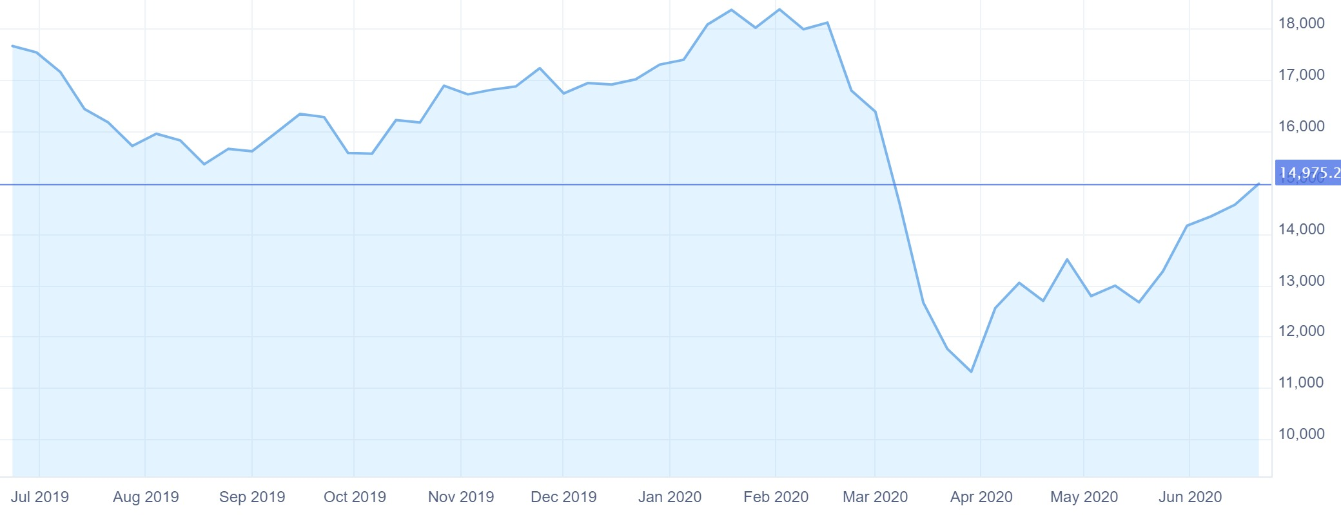

**Nifty 500**

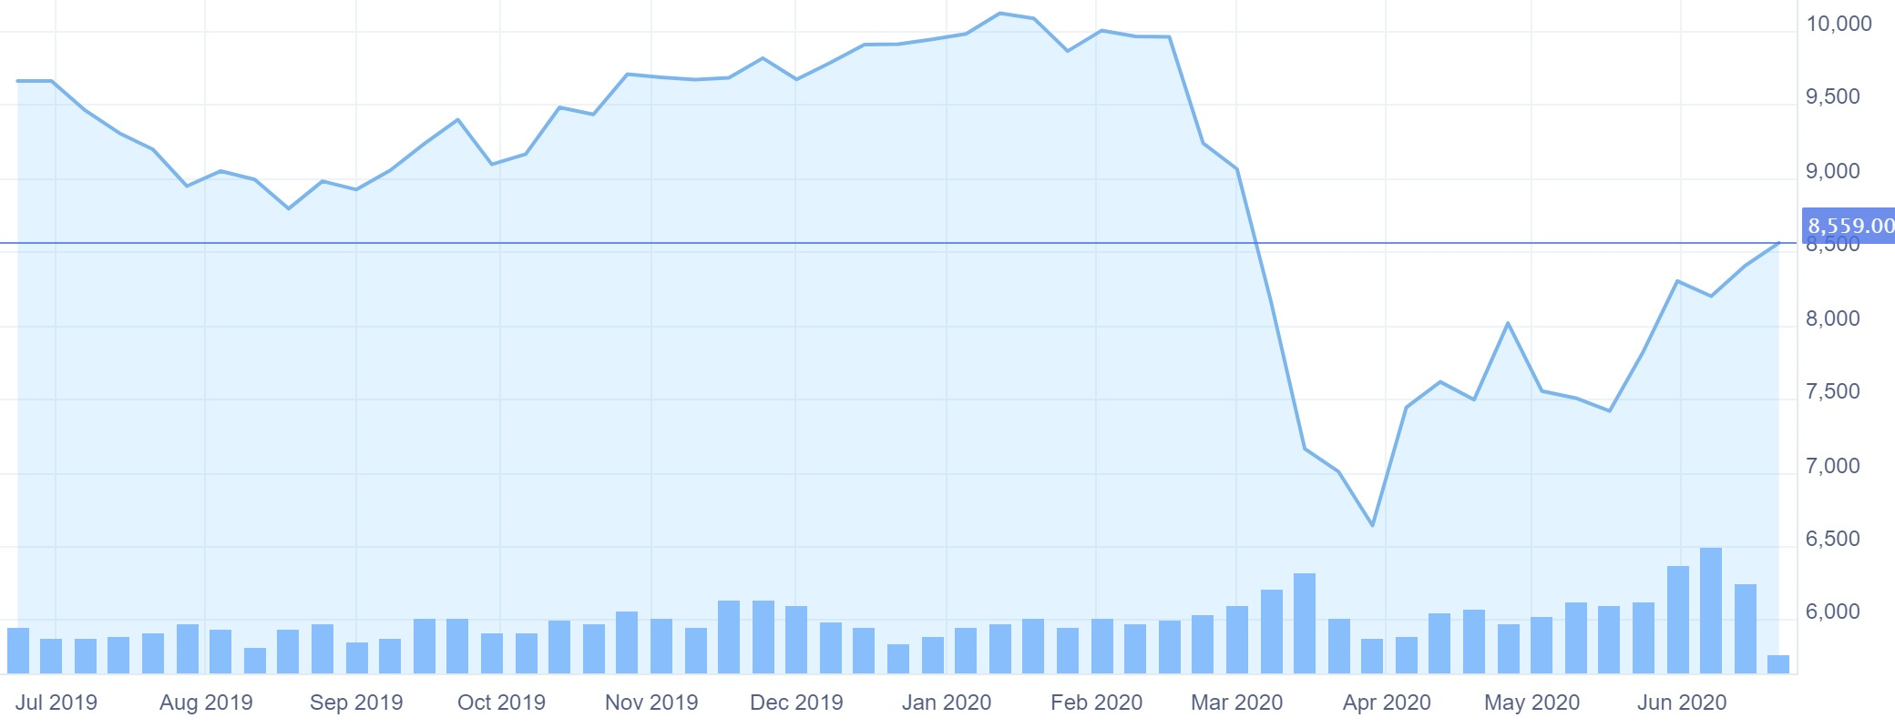

Sector Wise Report

* + - 1. **Auto**

**Nifty Auto**

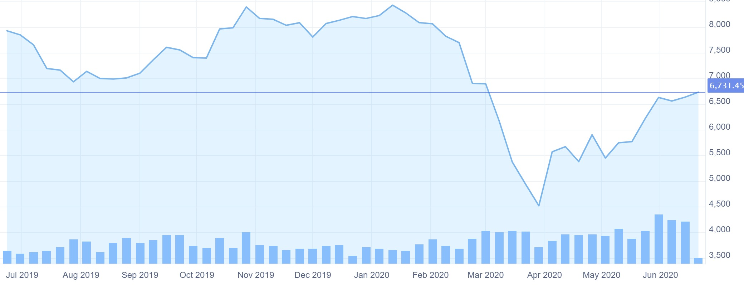

**BSE Auto**

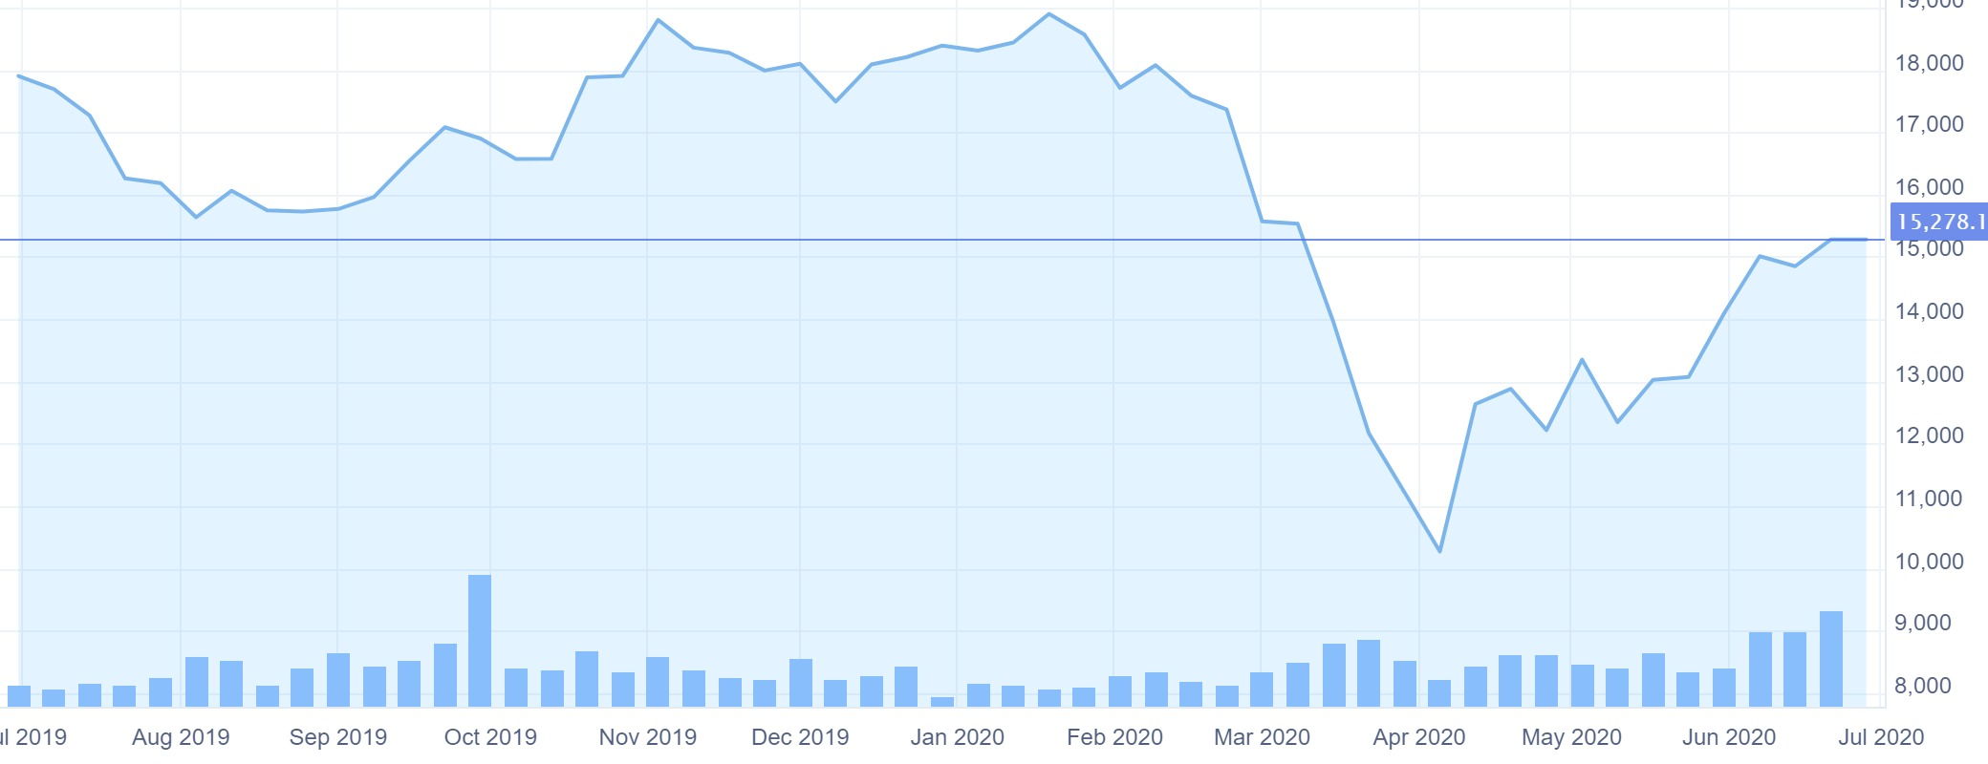

The automotive sector is globally integrated, and therefore the effects of the pandemic have been swift and significant. Initial disruptions in Chinese parts exports quickly evolved into large scale manufacturing interruptions across Europe. In the US, assembly plant closures are pressurizing the global supply to the point where companies are at the risk of defaulting, requiring banks to step in. The effects of the health crisis will have potential effects through revised consumer preferences, demand shocks, stressed financial conditions and crashing commodity prices (oil price slash)

The automotive industry contributes 7.5% to the overall Indian GDP and accounts for 49% of the manufacturing sector. Most auto stocks have been down 40-70% since February 2020.

India is dependent upon China for a huge chunk of their exports, especially for the automobile industry. In 2018-19, an estimated $4.5 billion worth of auto-component imports was seen from China and a whopping 27% of the automotive parts are manufactured in China and imported to the Indian companies valued at $ 4.5 billion. However, according to the China Association of Automobile Manufacturers (CAAM) several automakers are facing complete shutdowns. Therefore, the current situation puts this relationship in a fragile position. Additionally, most operations in India have been shut down during the lockdown.

* + - 1. **Bank**

**Nifty Bank**

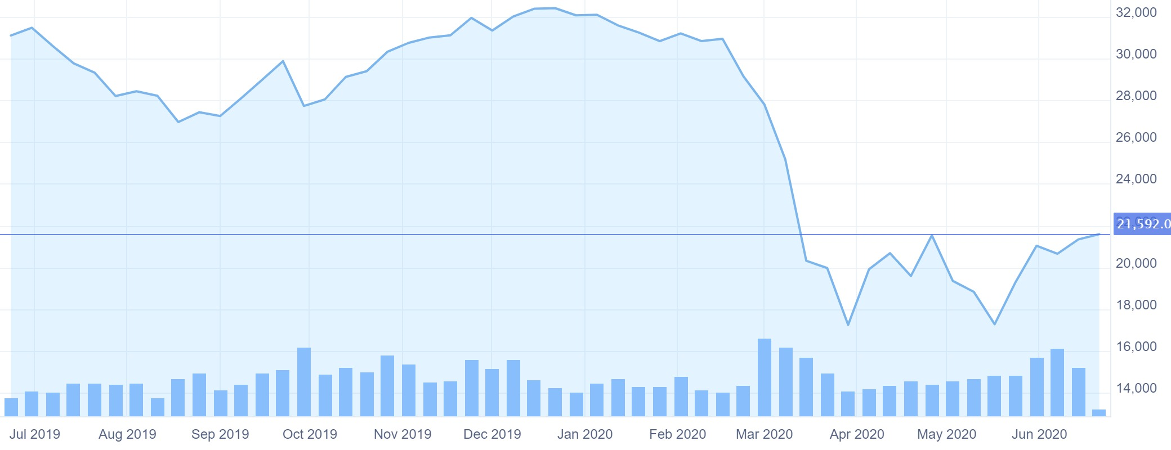

**BSE Bankex**

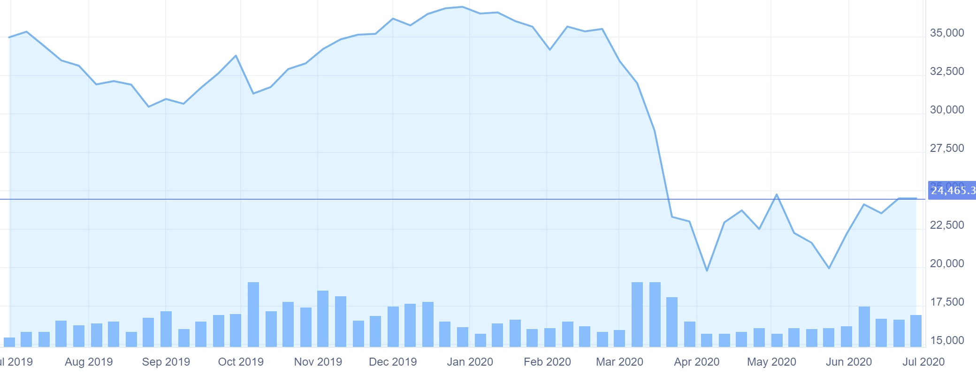

Banks were not as exposed as the corporate sector during the initial stage of the pandemic, the strain on lenders could ultimately be profound. Banks face a second-order hit compared with the corporate and household sectors. Asia-Pacific governments, central banks, and supervisory authorities have rolled out diverse measures to address COVID-19. These include liquidity injections, targeted loans to affected industries and regions, and policy rate cuts. It also includes support for banks to provide forbearance to otherwise economically viable households and businesses sideswiped by COVID-19.

The RBI in its seventh bi-monthly monetary policy announced on March 27, reduced the repo rate by 75 basis points to 4.40 per cent. It announced to provide Rs 3.74 lakh crore liquidity to banks through reduction in cash reserve ratio, by conducting targeted long-term repos operations (TLTRO) and by increasing the limit for marginal standing facility (MSF) to 3 per cent. RBI also allowed a repayment moratorium for three months on all term loans outstanding as on March 1, 2020, to borrowers of all commercial banks, including regional rural banks, small finance banks and local area banks, co-operative banks, and NBFCs, including housing finance companies and micro-finance institutions.[8]

Banks in India are likely to witness a spike in their non-performing assets ratio by 1.9 per cent and credit cost ratios by 130 basis points in 2020, a S&P Global Ratings report said. Investor sentiments are at an all-time low and it is also becoming evident how difficult it is going to be for banks all over the world to maintain good assets and good earnings.

1. **Energy Sector**

**Nifty Energy**

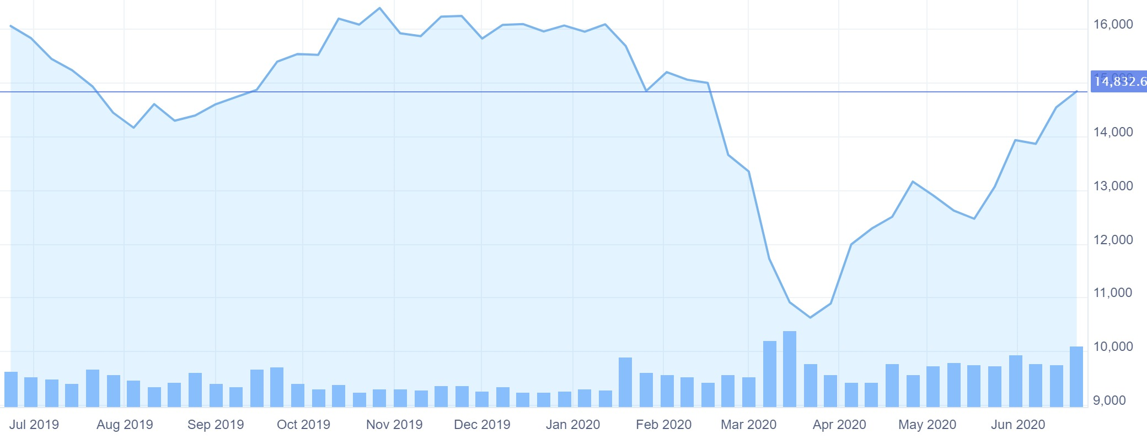

**Nifty Commodities**

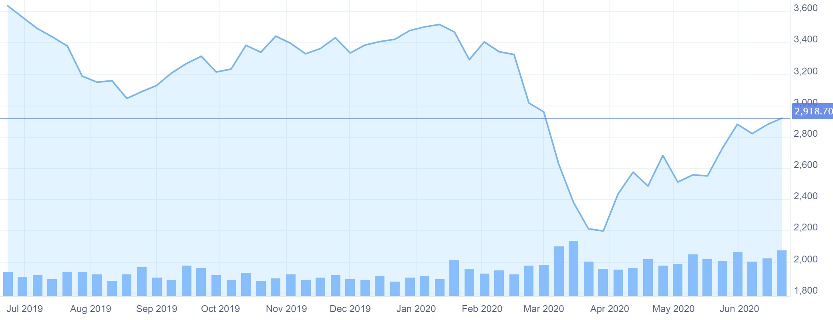

**BSE Power**

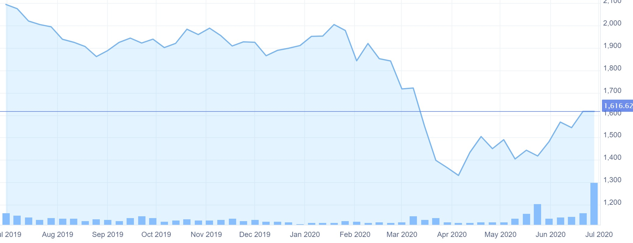

**BSE Oil and Gas**

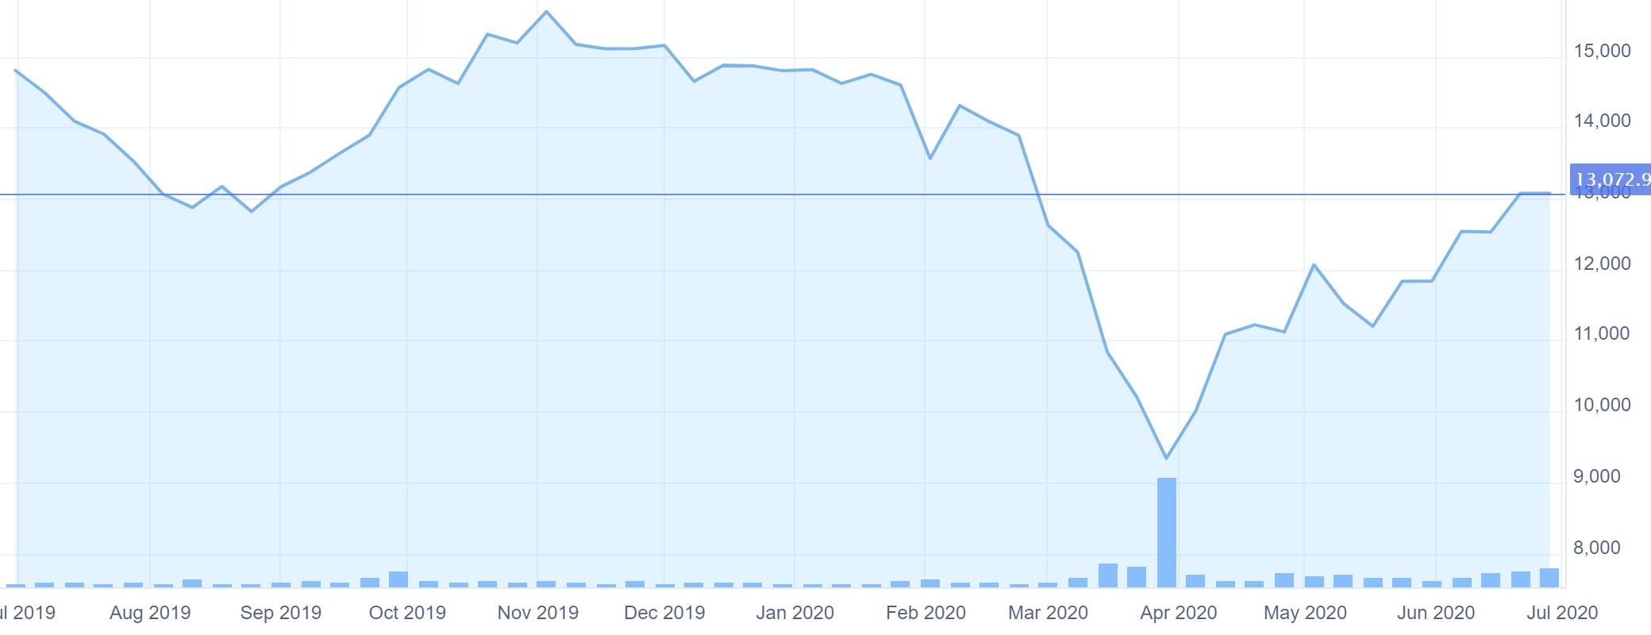

The coronavirus outbreak has contributed to a dampened demand for oil, resulting in plummeting prices and declining production, especially in the wake of the Russia-OPEC price war. According to the IEA Oil Market Report – April 2020, global oil demand is expected to fall by a record 9.3 mb/d year-on-year in 2020. Demand in May is estimated to be 29 mb/d lower than a year ago, down to a level last seen in 1995. Covid-19 has also accelerated the continued drop of gas prices.[9]

A similar trend of falling demand and price reduction can be observed in the electricity sector.

Many companies across different sectors globally have ceased or decreased capital expenditures where possible, and the energy sector is no exception. Non-critical investments have been suspended. In many countries (including all but two Contracting Parties of the Energy Community), customers have been advised by energy regulators and governments to delay the payment of utility bills. Defaults on payments cause cascade effect and impact the whole sector.[10]

India’s energy sector has shown surprising resilience in the face of the COVID-19 pandemic with supplies holding up admirably despite the global turmoil in financial and commodity markets. From oil wells and mines to nozzles and burner tips, the energy supply chain has remained steady. This, however, has come at a cost. Energy demand has dipped sharply as nearly one-third of the global population stayed indoors. Supply, which was already surpassing requirements and thereby putting pressure on prices, has now been deeply impacted by the demand fall-off. Brent crude, the relevant marker oil prices for India and the region, is at a twenty-year low. West Texas Intermediate (WTI), the U.S. marker, dropped below zero on the back of shrinking energy storage and unwinding of forward contracts. Across the world, supertanker ships are serving as floating storage. While the electricity sector has been largely insulated from oil price fluctuations, the sudden dip in revenue and cash collections have left most Indian energy companies financially imperilled. Demand for energy commodities has dropped by 25 to 30 per cent during the lockdown according to KPMG in India estimates, leading to plant closures and inventory pile up.[11]

However, recovery is likely to take place as the lockdown lifts and the energy supply chain resumes activity. The renewable energy sector is expected to bounce back quickly as the long-term drivers for investment remain strong, according to an EY report.

1. **FMCG Sector**

**Nifty FMCG**

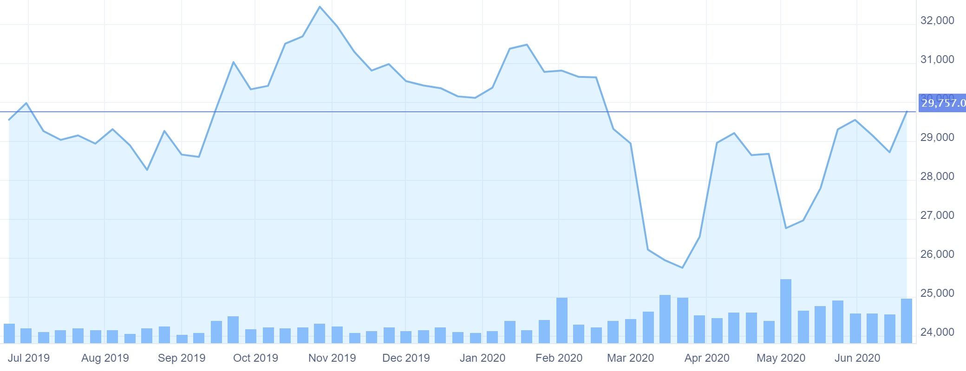

**BSE FMCG**

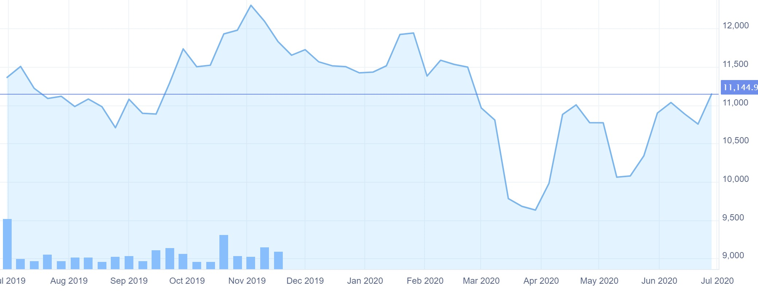

In the three months ended March, India’s fast-moving consumer goods sector grew 6.3% (including e-commerce) in value terms, down sharply from the 13.8% growth the sector saw in the year-ago period. While January and February saw growth rates improve from the December quarter, the spread of covid-19 in March hit sales of fast-moving consumer goods. In March, volumes grew a mere 0.5%, while the sector clocked a value growth of 4%.[12]

Throughout the pandemic, consumer demand has differed across product categories. While the relatively inelastic demand for traditional products such as personal care and hygiene items has driven growth, the discretionary categories have witnessed a decline, depressing overall sales. McKinsey estimates that an unprecedented 40-50 percent decline in discretionary spending could, in fact, translate to an 8 -13 percent drop in GDP.

Consumers have also grown more price-sensitive and have exhibited a larger propensity to buy local and engage in conscious, savings-driven consumption. On an average, consumers now spend greater time shopping online and indulge in deal-seeking as they look out for the best promotional offers and discounts online. Brand loyalty has taken a hit and brand-switching to cheaper and more readily available options has been observed in almost every second buyer.

Short-term supply-side constraints in the form of plant and warehouse shutdowns, shortage and restriction of movement of Carrying & Forwarding Agents (CFAs) and distributors has resulted in the contraction and disruption of supply chains in the sector.

The FMCG industry in India, for instance, witnessed a sharp decline to the tune of 34 per cent in sales in April as their traditional retail channels were severely impacted. On the other hand, modern trade registered nominal growth, partly supported by a mild recovery in cash & carry and e-commerce distribution channels as gradual regulatory moderations were made and companies adopted innovative methods for both B2B and B2C deliveries as consumer demand shifted. This global health crisis has shown that the demand for consumer products, especially personal care and hygiene segments, is likely to persist in the medium term as well. [13]

1. **IT Sector**

**Nifty IT**

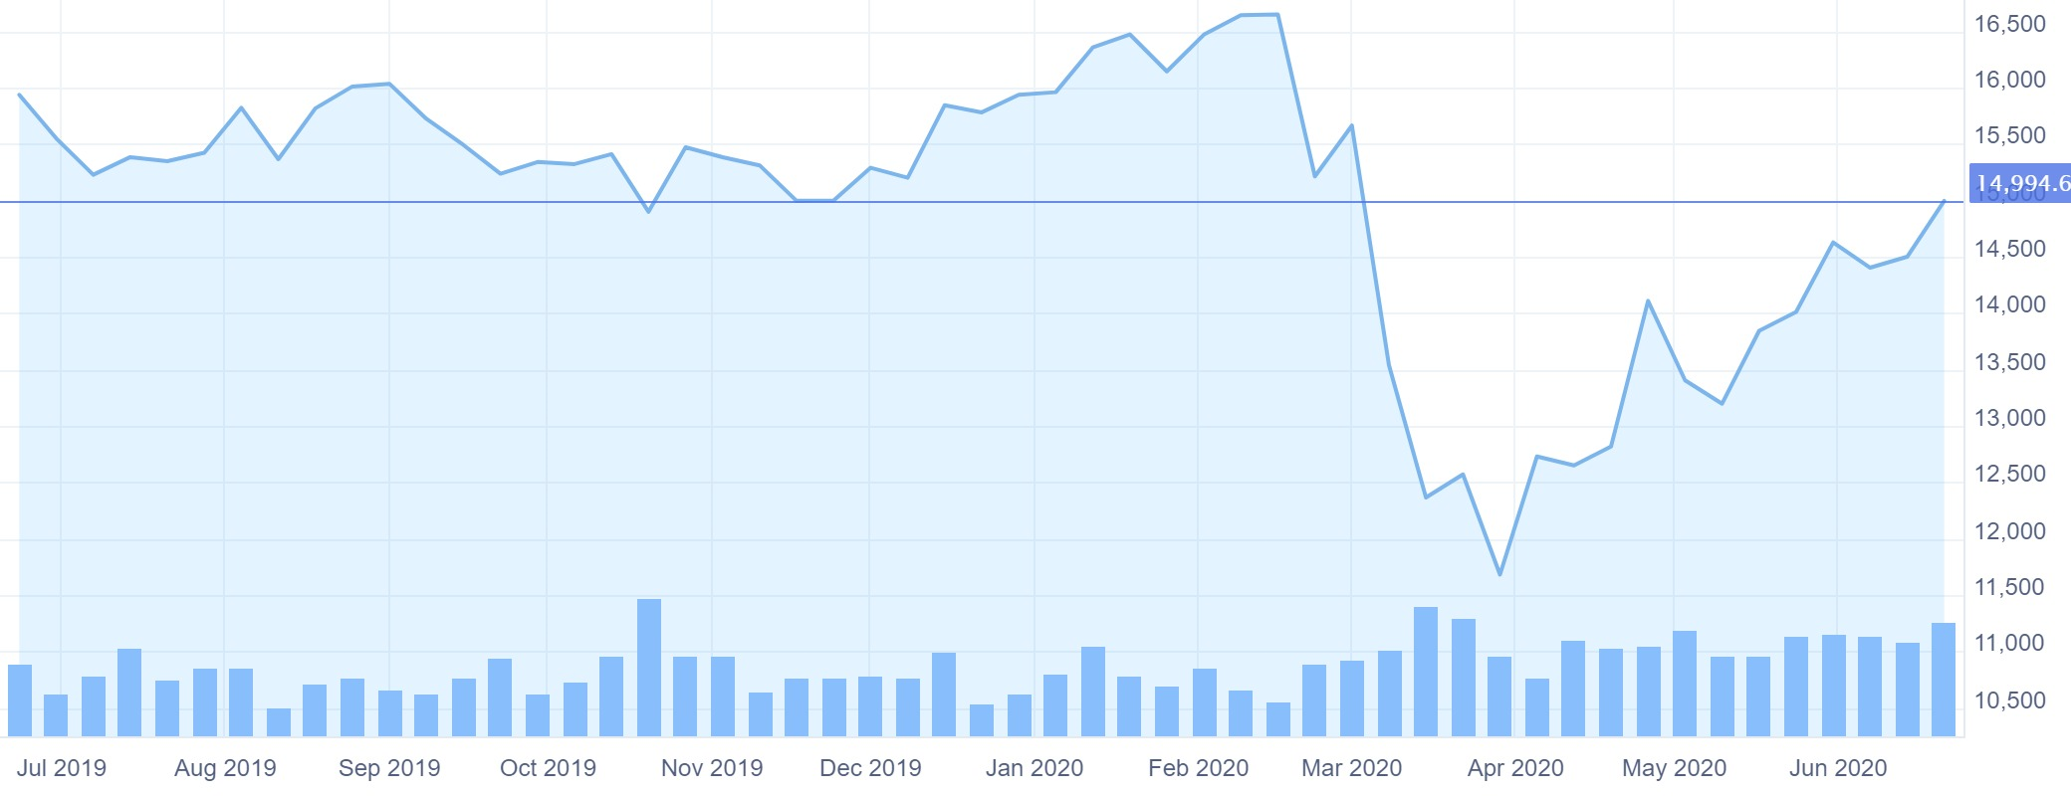

**BSE IT**

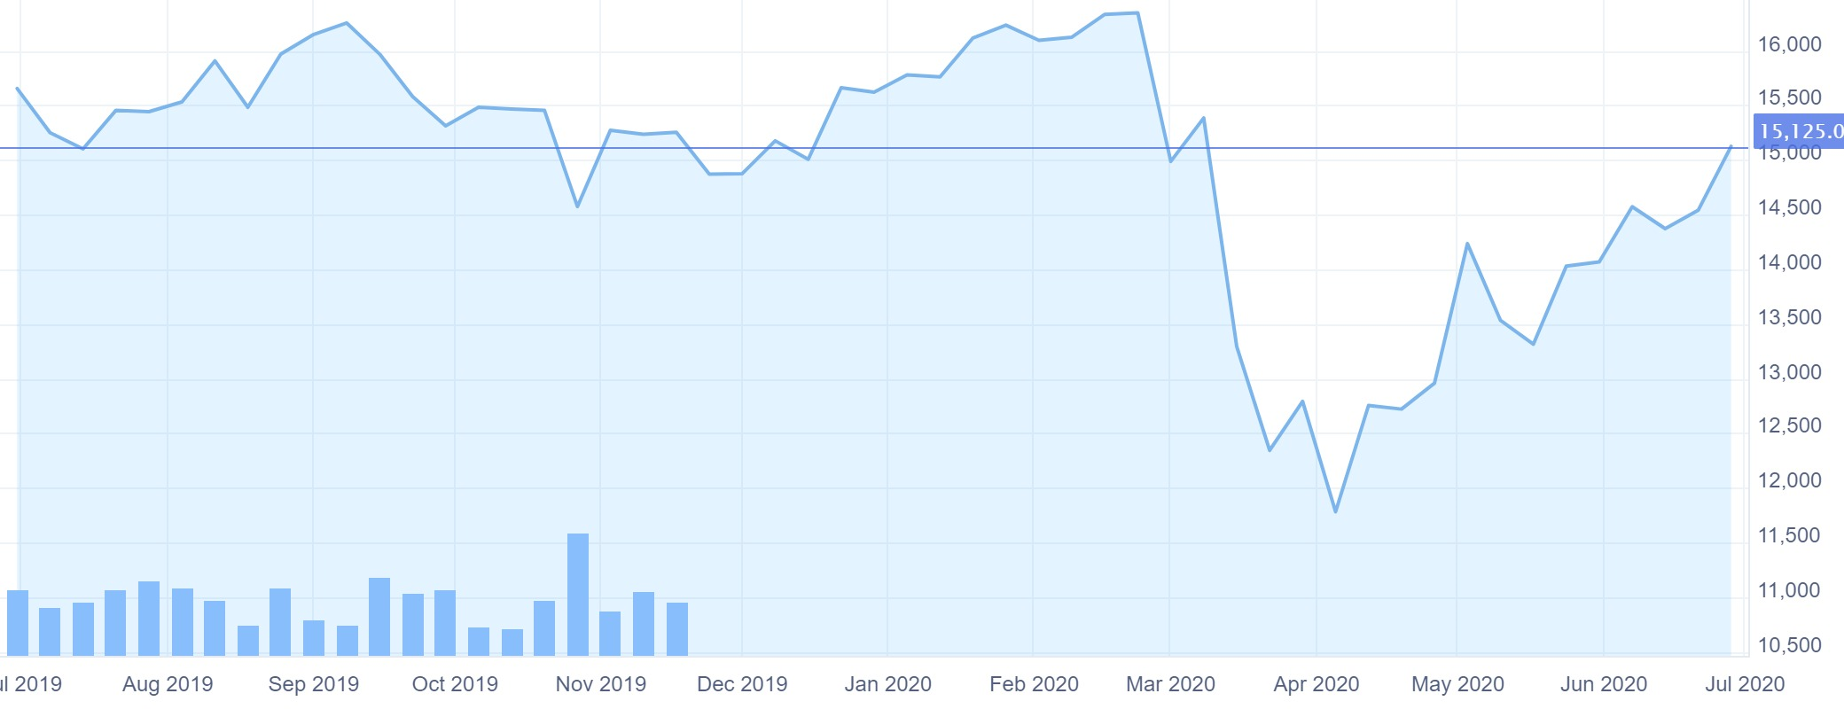

The Covid19 pandemic shrank the IT industry in a manner that internal investments into new projects, funding and administration expenditures were contracted. However, the industry toiled through the lockdown with most IT professionals continuing to work from home.

While the COVID-19 pandemic has eroded deal market expectations for some technology, media and entertainment and telecoms (TMT) executives, increased demand for virtual services and appetite for technology investment has offset some of the immediate challenges for many subsectors.

The IT industry holds promise even after the pandemic is over as demand for virtual services and technology investments to that end are expected to grow. Businesses -- mainly those in the services sector like banking & other financial services, education, retail, healthcare, food & grocery delivery -- will further embrace technology and automation to better leverage growth. Many organizations through rapid adoption of digital transformation have already embraced cloud and mobility trends. The expanding information technology (IT) industry, along with the rising trend of digitalisation, is one of the key factors that will continue to drive growth of IT companies.[14]

1. **Metals sector**

**Nifty Metals**

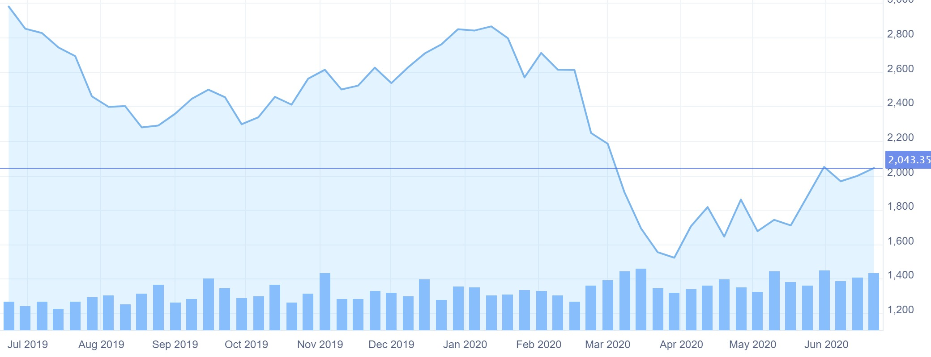

**BSE Metals**

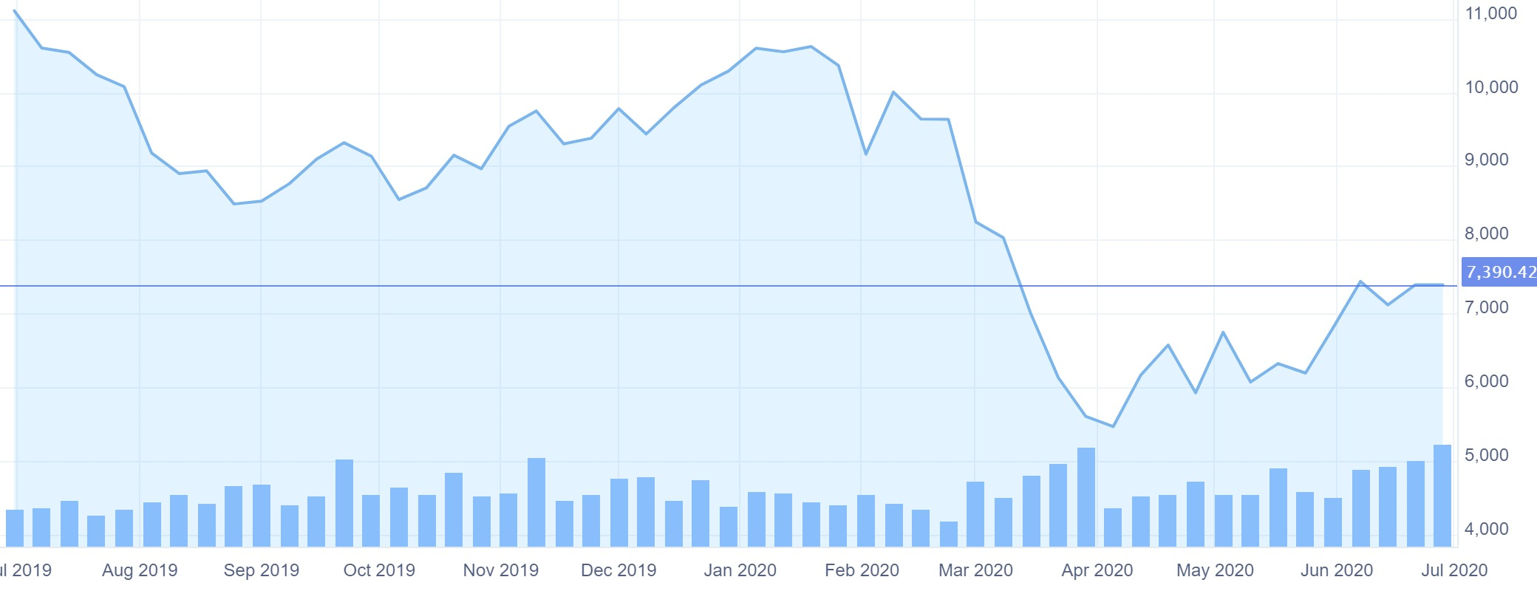Performance of metal sector is a key economic indicator which measures the depth of economy. The sector has been underperforming since last few years due to US-China trade deal, subdued growth and muted demand. But what puts further questions on this sector’s growth is impact of COVID-19.

Primarily, metal sector is struggling with over-supply, lower demand, thus leading to low prices of metals and continuously rising inventories. Now that the lockdown is being lifted in a phased manner, there is a possibility of revival in coming few quarters. However, prices are expected to remain on the muted side until there is a major surge in demand or sharp off-loading in inventory volume. This has put a heavy toll on the stocks and metal index corrected around 65 percent from 2018 highs and made its bottom in March 2020.

As sector is highly dependent on many other peripheral sectors, demand accounted is sizable and directly impacts consuming sectors, hence, the collapse of demand from various industries have left sector stranded. Amidst this crisis, most consumers and industries have postponed discretionary spending, plus there is a muted demand in all industries, barring essentials such as groceries and FMCGs has put a pressure on the sector.

Metal sectors’ revival is very much dependent on how aggressively government resumes its spending on infrastructure sectors and how fast it also stars executing the new projects. During the lockdown most of the large steel companies such as JSW Steel, Tata Steel, Jindal steel and power, tried to maintain their production, but other companies failed to keep it up and running. Now the major concerns would be shortage of labor as many have returned back to their native states and companies might face a challenge in bringing them back early.

Since the sector has seen the worst and economy is opening up, there is a fair chance that the sector would perform well in short to medium term. Stocks like Tata Steel, Hindalco and Mishra Dhatu Nigam (MIDHANI) are positioned at attractive valuations and might give good returns over the time.[15]

1. **Healthcare and Pharma**

**Nifty Pharma**

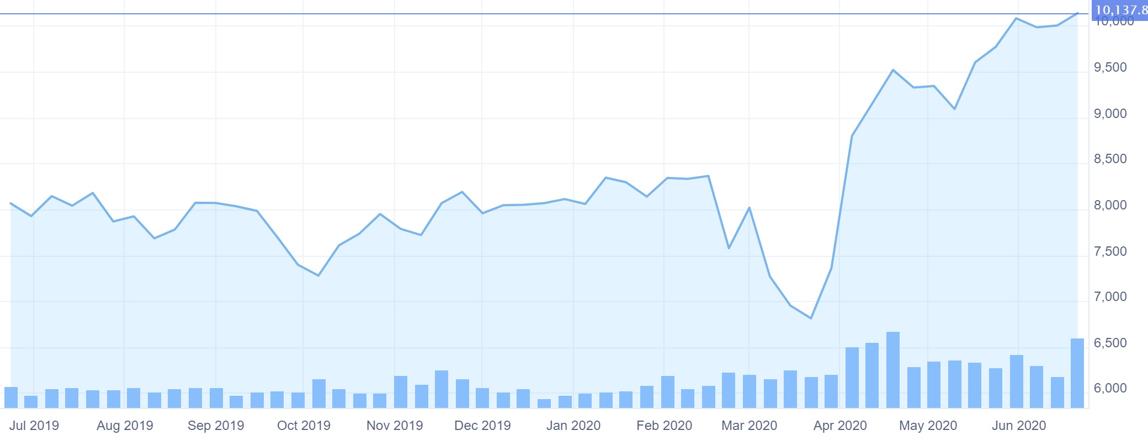

**BSE Healthcare**

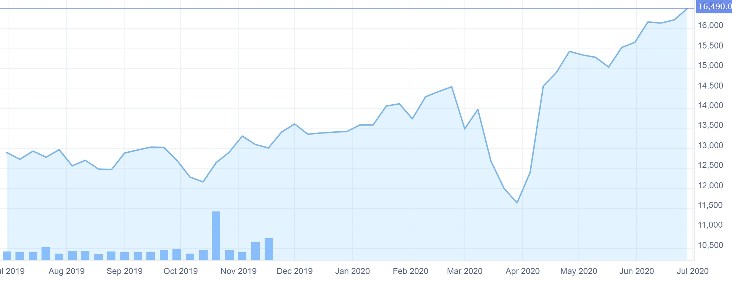

The Indian pharma industry has been a world leader in generics both globally and in domestic markets contributing significantly to the global demand for generics in terms of volume. Made-in-India drugs supplied to the developed economies such as the US, EU and Japan are known for their safety and quality. HDFC Securities says Indian pharma has been relatively resilient to the Covid disruption, and is poised to gain from favourable currency tailwinds and stable outlook for India and US businesses.[16]

Given that, the pharma industry is also highly dependent on china for APIs (active pharmaceutical ingredients), and any disruption to the supply of these can result in significant shortages.

The healthcare sector is at the epicentre of this unprecedented global pandemic challenge, and the private sector has risen to the occasion, by offering to the government all the support it needs, be it testing support, preparing isolation beds for the treatment of Covid-19 positive patients or deploying equipment and staff in identified nodal hospitals.

While the private healthcare sector is fully prepared for every eventuality, it is also a reality that, unlike other sectors, the sector is facing a twin-burden: (a) Investing additional manpower, equipment, consumables and other resources to ensure 100 per cent preparedness for safety in the hospital(s) and eventual treatment of patients, if needed. (b) Experiencing a sharp drop in OP footfalls, elective surgeries and international patients.

The medical devices industry has also taken a hit. The country imports consumables, disposables and capital equipment including orthopaedic implants, gloves, syringes, bandages, computed tomography and magnetic resonance imaging devices from China. Due to the current crisis in China, the medical device manufacturers across India are finding it difficult to source important raw materials and electronic components from Chinese factories. This is adversely affecting the margins and profitability of Indian companies importing medical devices and small components to manufacture finished products. This can also put upward pressure on prices of medical devices in the short term.[17]

1. **Realty Sector**

**Nifty Realty**

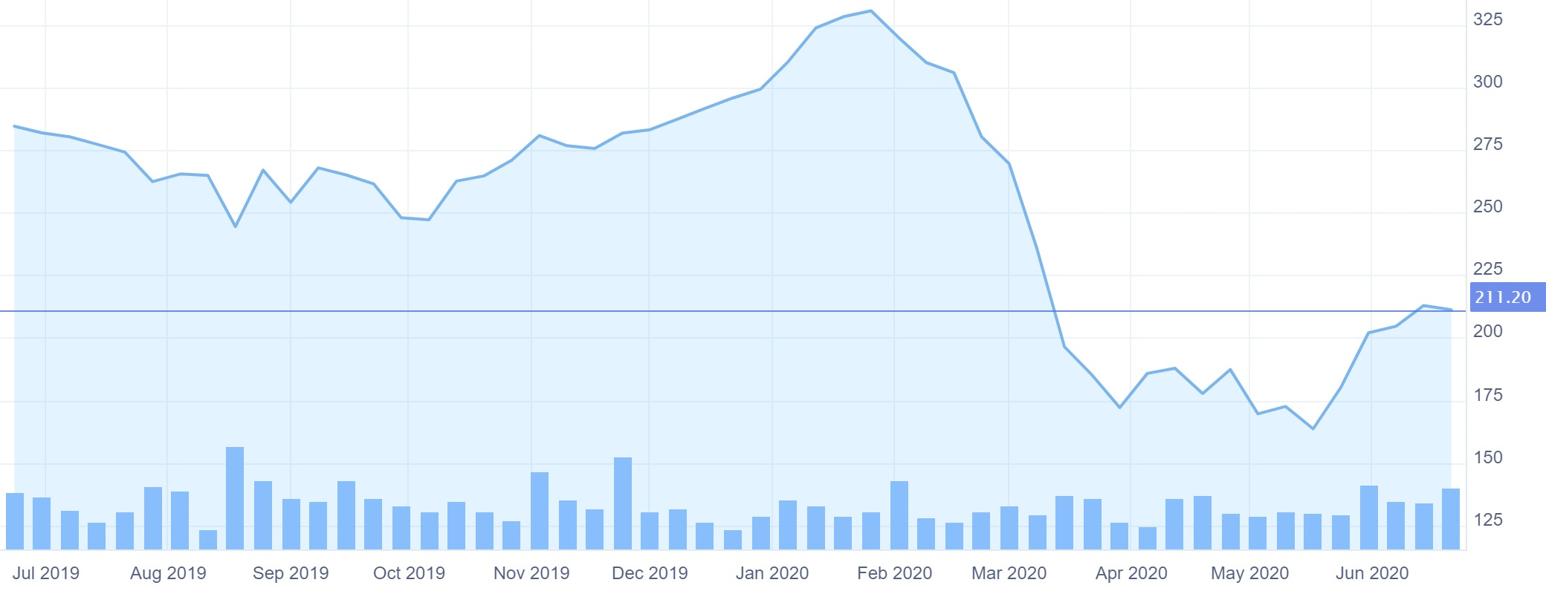

**BSE Realty**

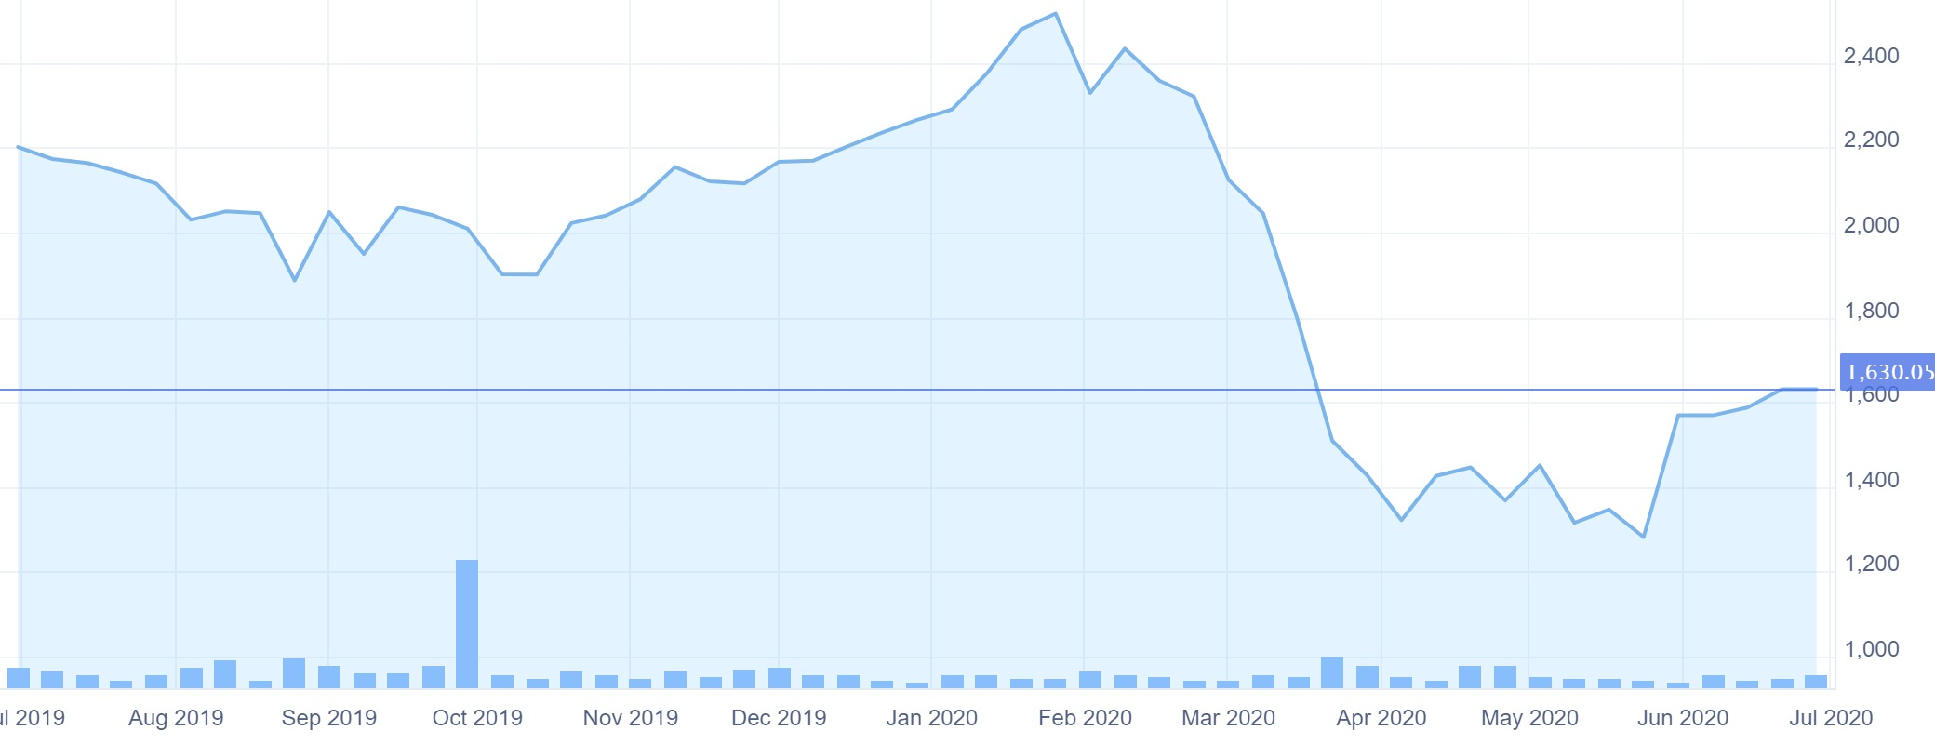

The impact of the novel Coronavirus on Indian real estate has been unprecedented to an extent that it has brought construction activities to a halt and significantly eroded the market of its potential buyer-base. With property transactions dipping to near-zero during the nation-wide lockdown, the sector is looking at challenging times ahead. The interdependence of supply chains, migration of labourers, cost overruns, and liquidity constraints are some of the looming challenges.

Despite an increase in the cost of construction and uncertainties around labour returning to metro cities from their hometowns post-lockdown, property prices are expected to see corrections, owing to marred buyer sentiment and panic selling by some homeowners in the resale market. New project launches are expected to get postponed till the festive month of October and it is highly unlikely that they will contribute enough to move average selling prices up in various cities.

However, the outbreak has now gripped the entire world into its clutches and the number of infections is increasing in India at a worrisome pace. If we take into account the short-term impact of the outbreak, the real estate sector has received a serious setback in the first quarter (Q1) of 2020. If the FICCI-NAREDCO real estate sentiment index for Q1 2020 is considered, the current sentiment of real estate stakeholders is at an all-time low score of 31.

**Mutual Funds**

The economic disruption brought about by the Covid-19 lockdown has been roiling the Indian stock market since March, but now the contagion seems to have spread to mutual funds – a favorite of risk-averse investors.

In a surprise move, Franklin Templeton Mutual Fund has decided to wind up six debt schemes with a combined asset base of 258.56 billion rupees (US$ 3.4 billion). The Indian arm of the US fund group announced that it was due to redemption pressure and a lack of liquidity in debt markets. The total asset under management of Franklin Templeton in India is 1.04 trillion rupees ($ 13.62 billion) as of March 2020.

Franklin Templeton officials said they were finding it difficult to generate liquidity in the current market scenario and that continuing to operate the funds would negatively impact existing investors. The six yield-oriented schemes in which investments have been stopped include the Franklin India Low Duration Fund, Dynamic Accrual Fund, Credit Risk Fund, Short Term Income Plan, Ultra Short Bond Fund and Income Opportunities Fund.

The funds invest in lower-rated bonds offering high interest rates. Investors will no longer be allowed to make fresh purchases or sales from these funds. The fund house is expected to make payouts to investors in a staggered manner.

This development is expected to create a stir in the debt market and market experts fear many investors will get nervous and redeem their funds. This is expected to put pressure on the debt market.

The industry body Association of Mutual Funds in India has rushed to allay investor concerns regarding debt funds floated by other mutual fund houses. This March the redemption pressure on debt mutual funds was the highest (1.94 trillion rupees or $25.4 billion) for the closing month of any financial year.[18]

According to data compiled by Morningstar India, all the equity scheme categories -- equity linked saving scheme (ELSS), mid-cap, large & mid-cap, large-cap, small-cap, mid-cap and multi-cap have given negative return in the range of 25-26 per cent between February 19 and March 18, 2020.

Individually, large and mid-cap funds have given a negative return of 26.63 per cent followed by large-cap (26.58 per cent), ELSS (26.47 per cent), multi-cap (26.45 per cent), small-cap (26.32 per cent) and mid-cap (24.84 per cent).

Notably, all the funds fell less than their respective benchmark indices during the bear market.

The 44-player mutual fund industry is not immune to the economic blowback of Covid-19, and going ahead, small and mid-cap equity schemes will continue to remain under pressure in the short to medium term on account of volatility in the markets.[19]

**Commodities**

Like equity and debt markets, commodities also faced its fair share of problems due to the coronavirus-induced lockdown. This period has been marked with widespread disruptions in trade, leading to sharp drawdown in prices of most commodities, barring gold.

**Gold Futures - Aug 20 (1 Kg prices)**

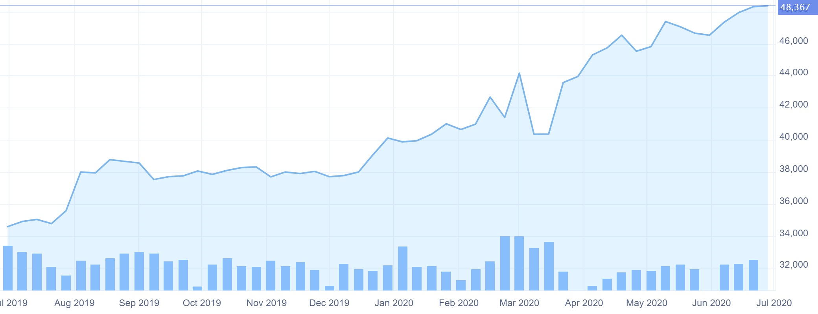

**Silver Futures - Sep 20 (1 Kg prices)**

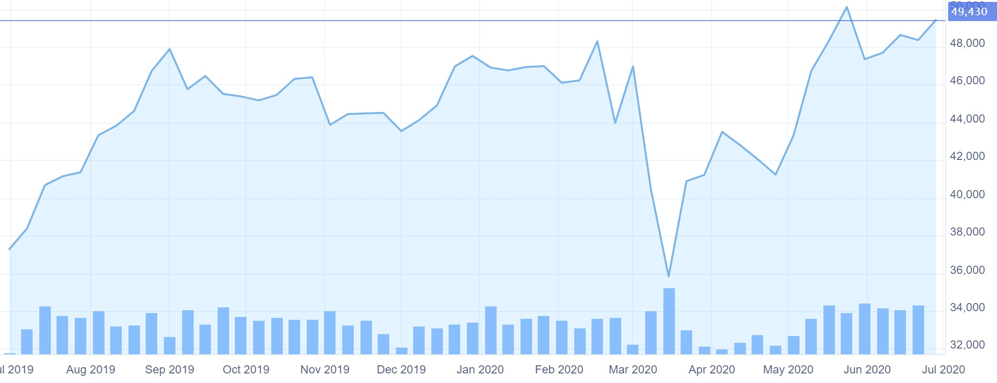

**Base Metals**

**Copper Futures - Jul 20 (1 Kg prices)**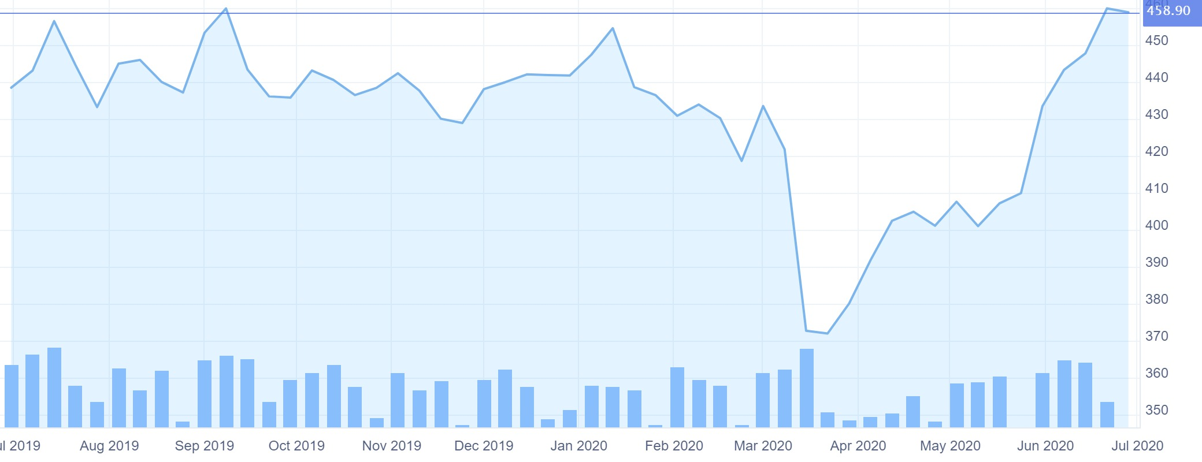

**Nickel Futures - Jul 20 (1 Kg prices)**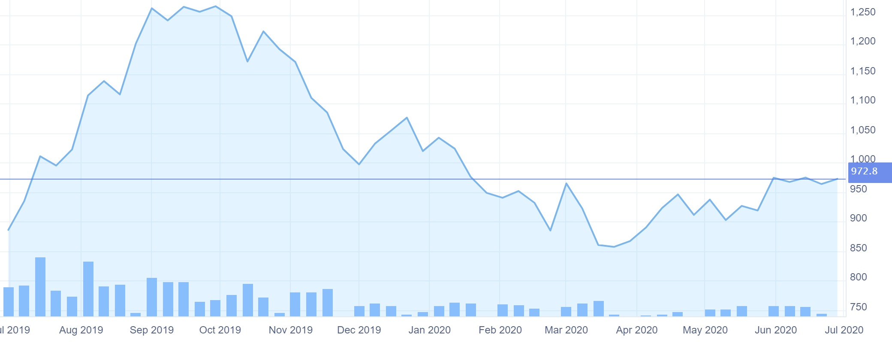

**Lead Futures - Jul 20 (1 Kg prices)**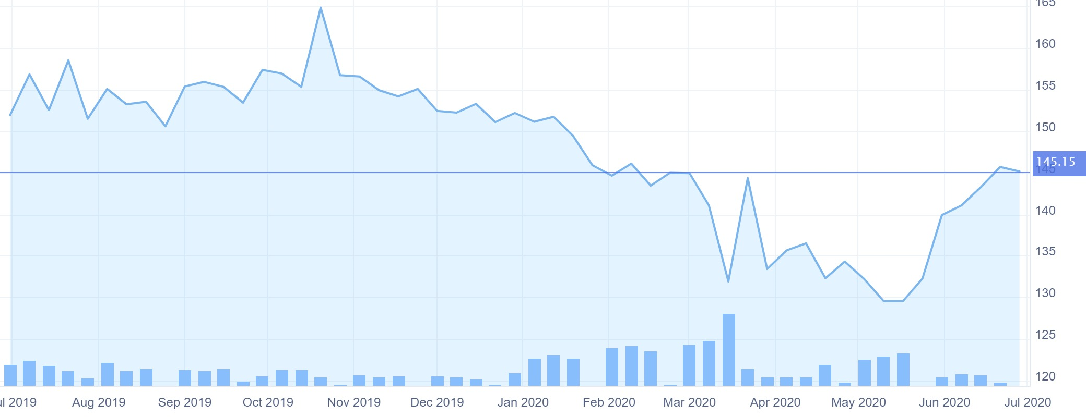

**Zinc Futures - Jul 20 (1 Kg prices)**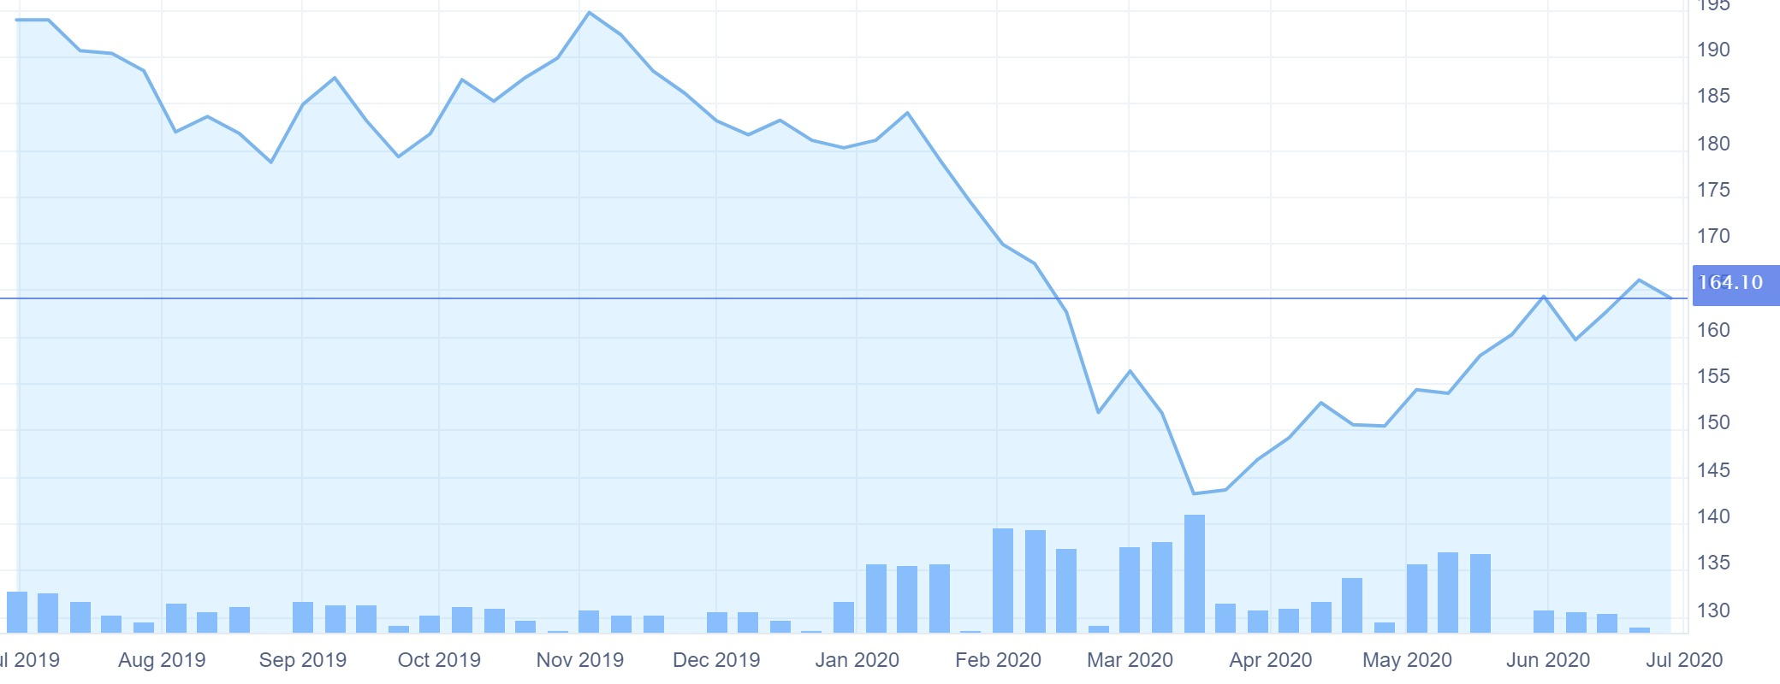

**Agri-commodities**

The lockdown has had a crippling effect on agri-commodities, as mandis had to be shut hampering price discovery. Demand destruction and shutdown of factories across the world led to a sharp drop in export demand for metals, foodgrains and spices.

**Jeera Futures - Jul 20 (Contract Size - 3 metric tonnes)**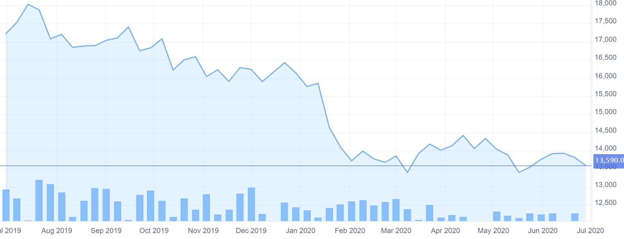

**Coriander Futures - Jul 20 (Contract Size - 10 metric tonnes)**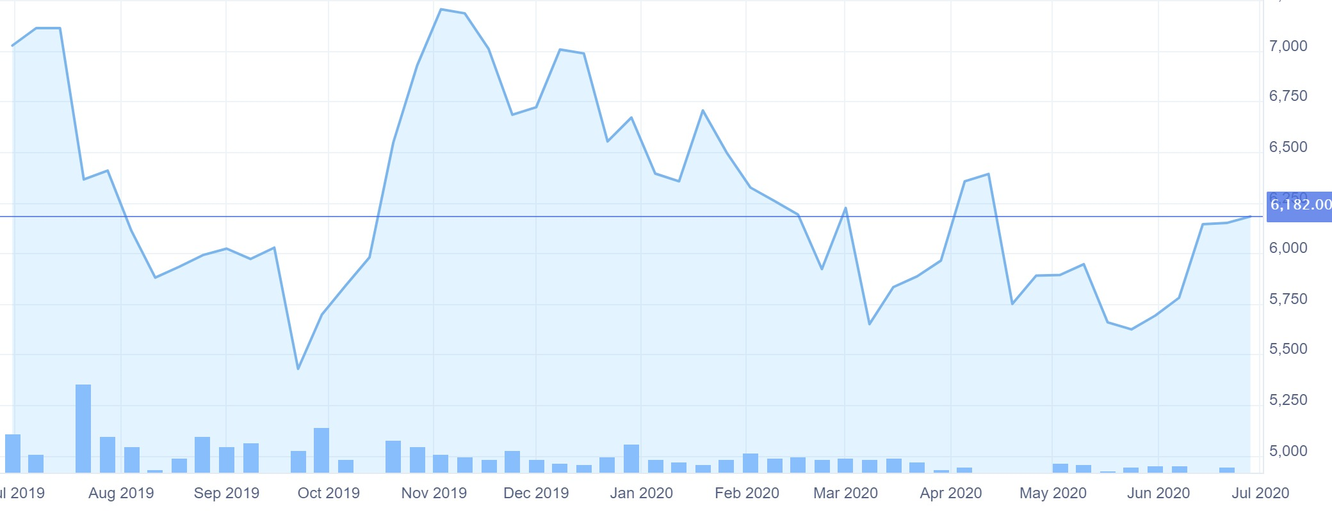

**Guar Gum Futures - Jul 20 (Contract Size - 1 metric tonne)**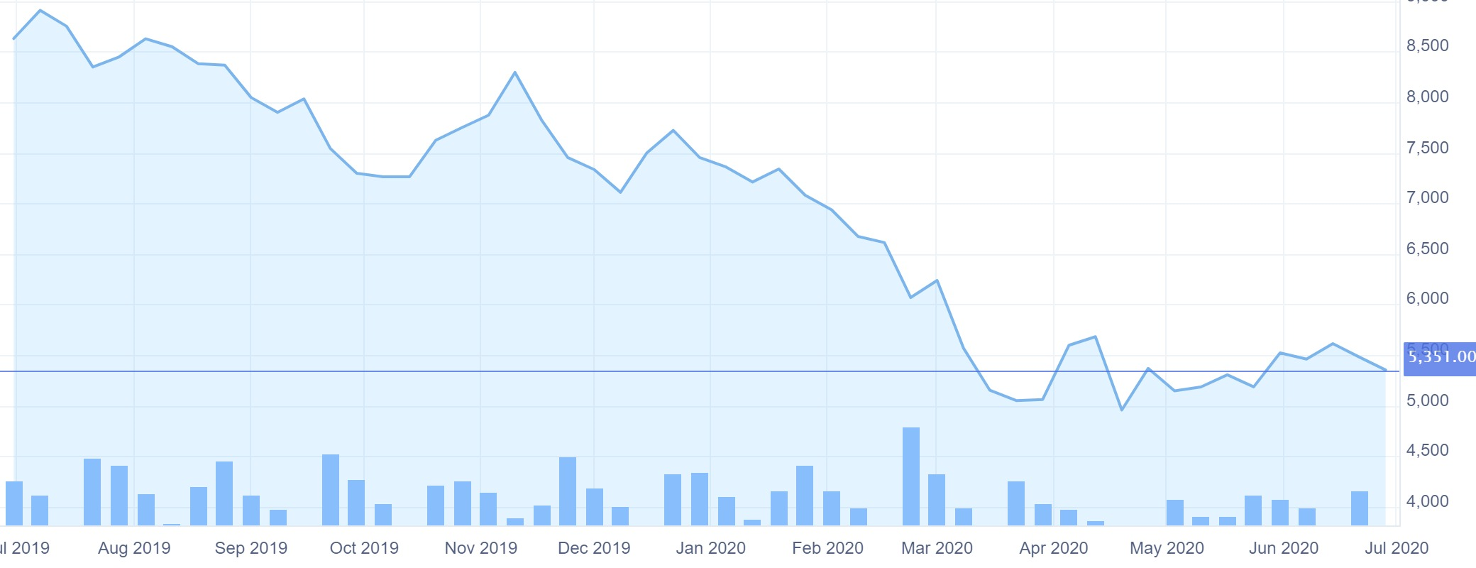

**Soybean Futures - Jul 20 (Contract Size - 10 metric tonnes)**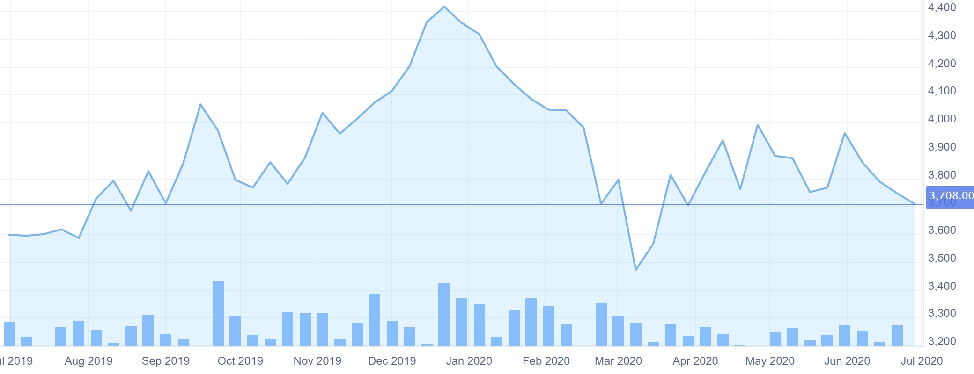

**Crude Oil WTI Futures - Jul 20 (Price per barrel)**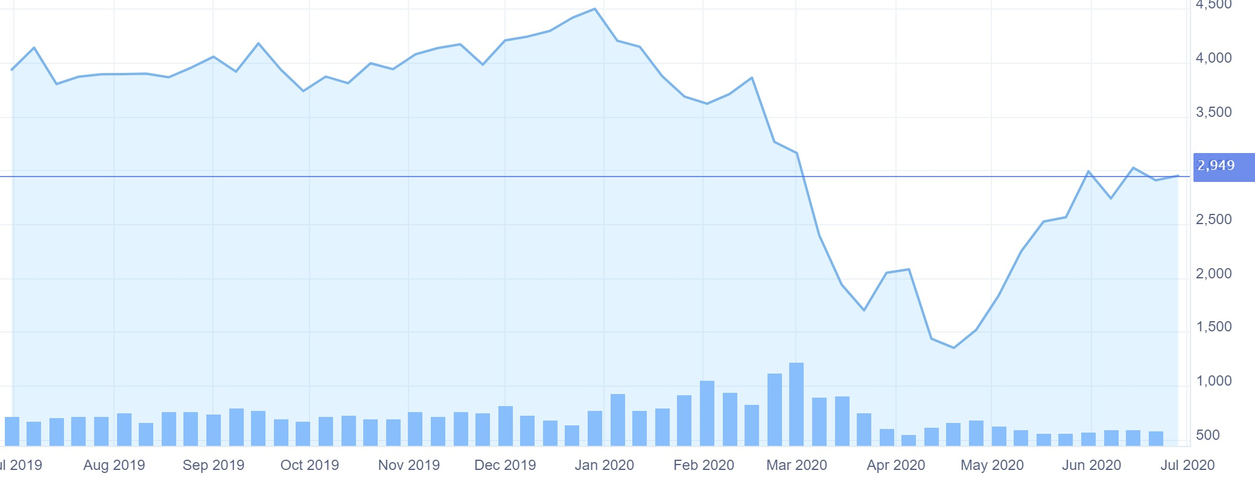

**Natural Gas Futures - Jul 20 (1 Mmbtu)**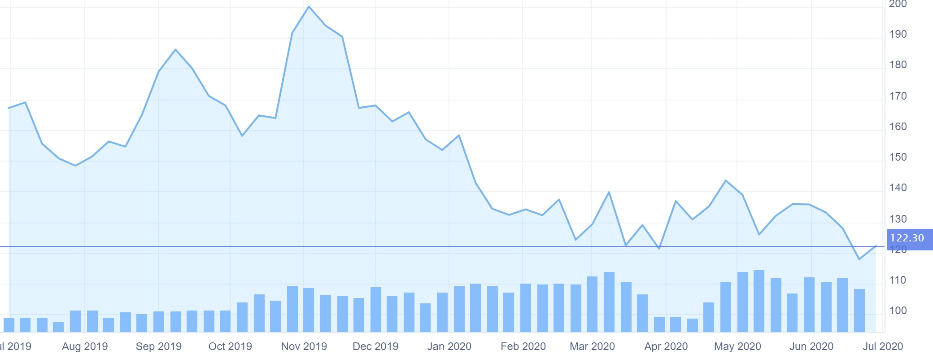

**Cryptocurrency**

Bitcoin values have shown considerable stability in the last couple of months. Peaking at $10,367.53 in mid-Feb and dropping to $4,994.70 in mid-March. According to Bitcoin experts like Nate Martin, the sharp rise and fall of the value of Bitcoin have little to do with the pandemic and its effect on the share market.

The seemingly erratic behaviour of the Bitcoin’s value is a result of the phenomenon miners and experts refer to as Halving. Bitcoin Halving occurs every 4 years or every time 210,000 blocks are mined. It occurred in 2012 and showed the same predictable fluctuations in the Bitcoin prices.

Unlike fiat currencies and assets, there are a fixed number of bitcoins to preserve their value. **The blockchain system is so designed that there will always be a fixed number of coins to be mined and there is little chance that economic crises, like the one COVID19, is bringing on, will have any impact on the value of these crypto assets.[20]**

**Conclusion**

All countries and sectors worldwide were affected due to the economic slowdown brought about by the Covid19 pandemic resulting in a global depression. The effects of the recession are yet to be determined; however, some regions/countries and/or industrial sectors will be hit harder than others. The only indices doing well despite the pandemic were Gold futures (gold is regarded as a safe haven for investments), Healthcare and pharma, as the pandemic demanded heavily from this sector and cryptocurrencies, which are unaffected by economic crises.



All historical data has been retrieved from Investing.com, Yahoo finance and S&P Global Indices Archives.

1. https://www.thebanker.com/Markets/Debt-capital-markets-enjoy-record-breaking-run
2. https://www.livemint.com/opinion/online-views/opinion-indian-debt-market-that-never-was-11587701684568.html
3. https://bfsi.economictimes.indiatimes.com/news/banking/covid-19-freezes-bond-market-yields-on-private-firms-paper-to-soar-more/74726910
4. https://www.thehindubusinessline.com/opinion/analysing-indias-corporate-bond-market-during-covid-19/article31738213.ece
5. https://www.business-standard.com/article/pf/more-gloom-for-savers-how-rbi-rate-cut-will-impact-fd-investments-savings-120052200477_1.html
6. https://www.financialexpress.com/money/government-securities-are-g-secs-better-than-fixed-deposits-for-retail-investors/1416785/
7. http://www.businessworld.in/article/Impact-Of-COVID-19-On-The-Indian-Stock-Markets/11-05-2020-191755/
8. https://economictimes.indiatimes.com/industry/banking/finance/banking/covid-19-impact-banks-to-witness-spike-in-credit-costs-non-performing-assets-in-2020/articleshow/75004720.cms?from=mdr
9. https://www.energyworldmag.com/the-impact-of-covid-19-crisis-on-global-energy-sector/
10. https://www.energyworldmag.com/the-impact-of-covid-19-crisis-on-global-energy-sector/
11. https://home.kpmg/in/en/home/insights/2020/06/the-energy-sector-post-covid-19-refueling-the-recovery.html
12. https://www.livemint.com/news/india/covid-19-impact-nielsen-slashes-2020-growth-forecast-for-fmcg-sector-to-5-6-11588236649931.html
13. https://www.investindia.gov.in/team-india-blogs/reimagining-consumer-goods-emerging-covid-driven-trends-and-road-ahead
14. https://economictimes.indiatimes.com/markets/stocks/news/covid-disruption-opportunity-for-it-much-bigger-than-the-risk-from-global-recession/articleshow/75771497.cms
15. https://www.msn.com/en-in/sports/cricket/will-metals-shine-after-covid-19-or-lose-their-lustre/ar-BB15jQPq
16. https://economictimes.indiatimes.com/markets/stocks/news/coronavirus-impact-on-indias-pharma-sector/articleshow/75136862.cms
17. https://economictimes.indiatimes.com/markets/stocks/news/coronavirus-impact-on-healthcare-sector/articleshow/75136714.cms
18. https://asiatimes.com/2020/04/covid-19-hits-indian-mutual-fund-firm/
19. https://economictimes.indiatimes.com/markets/stocks/news/coronavirus-equity-mutual-funds-give-25-negative-returns-to-investors/articleshow/74755971.cms
20. https://economictimes.indiatimes.com/small-biz/startups/newsbuzz/is-covid-19-the-biggest-opportunity-in-crypto-asset-trading/articleshow/75913576.cms